Benchmark survey of the New Zealand public’s knowledge and understanding of the First World War and its attitudes to centenary commemorations
Level 1, 6-10 The Strand
PO Box 33690 Takapuna 0740
Auckland. Ph 09 919 9200

Level 9, Sybase House, Lambton Quay
PO Box 3622, Wellington
Ph: 04 913 3000
www.colmarbrunton.co.nz

Report prepared for: | First World War Centenary Programme Office
Contact person: | Colmar Brunton
Date: | 4 March 2013

Table of Contents
Executive summary 3
Conclusions 6
Background and objectives 8
Research methodology 9
Survey results 11
Interest in history and engagement in learning about history 11
History 11
Local community history 13
Genealogy 15
Relevance of the First World War to New Zealand 17
Relevance in developing New Zealand’s national identity 17
Importance of Australian relationship to New Zealand’s history 19
Personal engagement with the First World War 21
Family involvement in First World War 21
Engagement with others about family’s experience in the First World War 23
Interest in finding out more about family’s involvement 24
Personal relevance of the First World War 25
Participation in First World War activities 27
Recall of recent mention of First World War 29
Top of mind associations 30
Top of mind associations with the First World War 30
Top of mind associations with New Zealand’s involvement in the First World War 32
Knowledge of the First World War 34
Self-reported knowledge of the First World War 34
Knowledge of meaning of Anzac acronym 37
Awareness of New Zealand’s occupation in Samoa 39
Awareness of First World War start and end dates 40
Awareness of First World War fronts and battles 42
Perceptions of where more New Zealanders were killed 44
First World War commemorations 46
Perceived importance of First World War commemorations 46
Awareness of Government funding of First World War commemorations 48
Lottery grants board funding 50
Likelihood of attending centenary events 52
Interest in exhibit types 55
Likelihood of visiting a recreation of First World War trench 56
Interest in national online database of First World War NZ soldiers 57
Interest in sharing memorabilia via national collection 59
Appendix A: Detailed sample profile 61

Appendix B: Final Questionnaire……………………………………………………………………………..…………………………………..…66

Executive summary

Background and objectives
The Ministry for Culture and Heritage’s First World War Centenary Programme Office, in conjunction with Te Papa and the Auckland War Memorial Museum, wishes to obtain a comprehensive understanding of New Zealanders’ knowledge, understanding and beliefs of the First World War, and their attitudes towards and interests in potential commemorative activities. In order to do this, the agencies commissioned Colmar Brunton to carry out an online survey of New Zealanders aged 15 years and over. At the end of the commemorative period, the combined agencies may commission a follow-up survey to assess whether or not these activities have enhanced New Zealanders’ knowledge and understanding of the War, and if so in what way.

Research methodology
In total, 4,017 New Zealanders aged 15 years and over completed an online survey from 22 November to 12 December, 2012. The maximum margin of error for a sample of 4,017 is +/-1.5% (at the 95% confidence level and assuming simple random sampling).
Data has been weighted by region, age, gender and ethnicity to ensure the sample is representative of the New Zealand population age 15+ on these variables.
The main limitation of the online survey methodology is that the sampling frame excludes people who do not have internet access (estimated to be between 15% and 25%). Lower socio-economic groups are especially prevalent among those without internet access. Therefore, it is important to acknowledge that the survey results provide an overall picture of the New Zealand public, but the survey cannot be said to be truly representative of all groups as online panels exclude New Zealand households without access to the internet.

Key results
Salient results from the research are presented below. Note, these do not include results for the fully open-ended questions. These are being analysed by the Ministry for Culture and Heritage and will be reported on separately from this report.

Interest in history and engagement in learning about history

History generally
- 88% of New Zealanders show some interest in history (rating of 3, 4 or 5 on a scale of 1 to 5 where 1 is ‘not at all interested’ and 5 is ‘very interested’). 58% show a stronger level of interest (4 or 5 out of 5).
- Among those who show an interest in history, the most common sources of learning about history are TV (79%), the Internet (72%) and books (67%) followed by visiting a museum (54%) and school (51% of 15-19 year olds).

Local community history
- 71% show some interest in the history of their local community (rating of 3, 4 or 5 on a scale of 1 to 5 where 1 is ‘not at all interested’ and 5 is ‘very interested’). 36% show a stronger level of interest (4 or 5 out of 5).
- Of those who are interested in the history of their local community, 42% have undertaken research, or looked into, the history of their local community. This equates to 30% of all respondents.
- The Internet (62% of those who have undertaken this type of research), library (61%) and local residents/knowledgeable people (56%) are the most commonly used resources.

Genealogy
- 80% of New Zealanders show some interest in family history/genealogy (rating of 3, 4 or 5 on a scale of 1 to 5 where 1 is ‘not at all interested’ and 5 is ‘very interested’). 54% show a stronger level of interest (4 or 5 out of 5).
- 19% of those who show some interest in genealogy have personally undertaken research into their genealogy. A further 58% say that someone else in their family has undertaken this type of research.
- Contact and conversations with family members (84%), Internet resources (81%) and family papers/documents (76%) are the most common sources used, with more than three quarters having used each of these sources.

Relevance of the First World War to New Zealand
- 77% of New Zealanders think that the First World War has some degree of relevance to New Zealand’s national identity (giving a rating of 3, 4 or 5 on a scale of 1 to 5 where 1 is ‘not at all relevant’ and 5 is ‘very relevant’). 53% view the War as more strongly relevant (4 or 5 out of 5).
- 85% of New Zealanders think the Australian relationship is important to New Zealand’s history (rating of 3, 4 or 5 out of 5 on a scale where 1 is ‘not at all important’ and 5 is ‘very important’).67% view the relationship as more strongly important (4 or 5 out of 5).

Personal engagement with the First World War

Family member who fought or served in the War
- 40% of New Zealanders have had a family member who served or fought in the First World War. This is most likely to have been a grandfather (14% of all respondents), great uncle (13%) or great grandfather (11%).
- 57% of those with a family member who served or fought in the First World War say they have talked to their family or friends about their family’s participation or experience during the First World War.
- 80% of those with a family member who served or fought in the First World War say they would like to find out more about their family’s involvement in the War.

Other personal engagement with the First World War
- 59% of New Zealanders perceive what happened in the First World War, and the outcome of the War, to be at least somewhat relevant to their life today (rating of 3, 4 or 5 out of 5 on a scale of 1 to 5 where 1 is ‘not at all relevant’ and 5 is ‘very relevant’).
- Virtually all (97%) respondents have taken part in at least one Anzac related activity. The most common activities are buying a poppy (89%) and watching a TV documentary about the First World War (78%).
- 51% of New Zealanders recall at least one communication channel through which the First World War was mentioned in the last three months. Television is the most common channel recalled (36%) followed by newspapers/magazines (19%), the Internet (17%) and radio (10%).

Knowledge of the First World War
- Self-reported knowledge of the First World War is as follows:
- 1% have never heard of the First World War
- 18% have heard of the First World War, but have no real knowledge of it
- 47% have a basic understanding of the First World War
- 24% know a reasonable amount about the First World War
- 6% have a reasonably advanced level of understanding about the First World War
- 1% have expert knowledge about the First World War.
- 90% correctly understand that Anzac is an acronym for Australian and New Zealand Army Corps.
- Only 26% are aware that New Zealand occupied Samoa in the First World War. This is substantially higher among New Zealanders of Samoan descent (72%).
- 48% know that the First World War began in 1914 and ended in 1918.
- In terms of fronts and battles of the First World War, the Battle of Gallipoli and the Gallipoli Front (79% and 63% respectively) are most well-known, with the Western Front (46%), the Battle of the Somme (45%), and the Battle of Passchendaele (43%) also receiving notable recall.
- Only 17% know that more New Zealanders were killed in the Western Front than Gallipoli. 52% believe it was Gallipoli.

First World War commemorations

Importance of commemorating the centenary
- 89% place some importance on New Zealand commemorating the centenary of the First World War (rating of 3, 4 or 5 out of 5 on a scale of 1 to 5 where 1 is ‘not at all important’ and 5 is ‘very important’). 48% consider it to be very important (5 out of 5).

Government funding
- Just 20% are aware that the Government will be funding some projects to commemorate the First World War. Awareness is highest for the development of the National War Memorial Park (69% of those aware of the government funding).
- While only 7% are aware of the Lottery Grants Board funding for community projects to commemorate the First World War, more than double (17%) say they, or a group they belong to, would consider organising something to commemorate the First World War.

Interest in participating in commemorations
- Likelihood of attending centenary events is highest for exhibitions at local museums (24% say they are very likely to visit one), a commemoration ceremony (21%), travelling exhibitions (20%), opportunities to explore family history related to the First World War (18%) and a film screening (17%).
- Among those interested in visiting exhibitions, photographic exhibitions (90%), survival stories (81%) and diaries (70%) hold the most appeal.
- 30% say they are very likely to go through a recreation of a First World War trench if it was at their local museum. A recreation of Gallipoli holds the most appeal (39% of those with some interest in a recreation of a First World War trench).
- 12% are very interested in using/and or contributing to a national online database that gathers the details of each New Zealand soldier who served in the First World War.
- 13% of New Zealanders have memorabilia from the First World War. Of these, 22% say they would be very interested in having the memorabilia copied into digital format for inclusion in a national collection that anyone could access online.

Conclusions

Opportunities to expand and correct knowledge of the First World War
This study serves as a useful benchmark of New Zealanders’ understanding of the First World War. Whilst nearly a third consider themselves to know at least a reasonable amount about the First World War, most New Zealanders’ understanding of the First World War is limited to a few basic facts. There are clear opportunities to expand knowledge (such as New Zealand’s occupation of Samoa) and in some instances to correct knowledge (such as the Western Front being the deadliest in New Zealand’s military history).

Broad levels of interest in different types of history point to sizeable potential audience
A number of research findings provide useful indicators of the potential audience for participation in commemorating the centenary of the First World War. A very large majority of New Zealanders show a general interest in history, and large – albeit somewhat smaller majorities – are interested in the history of their local community and their own family.
There is also considerable appreciation of the role and relevance of the First World War for today. Most New Zealanders perceive the War to have been relevant in shaping our national identity and a little over half of New Zealanders perceive it to be relevant to their life today. The research findings also reinforce the special place that Australia is perceived to have in shaping our history.
These findings suggest there is a fairly broad base on which to build awareness, interest and engagement with the centenary commemorations.

Interest in a range of commemorative activities – Gallipoli and facilitating a personal connection should feature strongly
We encourage the reader to interpret the findings related to interest in, and likelihood to attend, specific commemorative activities with care as respondents tend to over-state their behavioural intentions with these types of questions. Actual attendance/participation is not just driven by intention, but also by practical factors such as awareness, accessibility and the quality of the event.
Nevertheless, the research findings do point to healthy levels of interest in commemorative activities (especially exhibitions, commemorative services, and the recreation of a First World War trench).
Two themes emerge that provide insight into the types of things that will be especially effective in engaging New Zealanders: Gallipoli and a personal connection.
Gallipoli clearly holds a special place in our nation’s history. The research findings show that it is prominent in New Zealanders’ top of mind associations with the First World War, is perceived to be the most important front or battle of the First World War, and is the most preferred battle for a recreation of a trench.
The importance of a personal connection also emerges in the research findings. Of particular note, the types of exhibits that are of most interest to people (photographic exhibitions, survival stories and diaries) facilitate a more personal connection and appreciation of what it was like for those who fought or served in it.
There is also high interest among those with a family member who served or fought in the First World War to find out more about their family’s involvement in the War. Related to this, people’s interest in genealogy tends to be higher than their interest in their local community.

Marked variations in survey results by age
The body of the report details a number of interesting demographic patterns related to age, gender, ethnicity and region. Age is the most differentiating demographic variable, with older New Zealanders more interested in various types of history, more likely to perceive the First World War as relevant to New Zealand (and them personally) today, more knowledgeable about the First World War, more engaged with activities related to the First World War and more interested in getting involved with commemorative activities.
Whilst there are striking differences by age, it is important not to purely focus on the relativities between older and younger New Zealanders. The research findings show that there are still significant numbers of younger New Zealanders who are interested and engaged. For example, 67% of 15-19 year olds have been to an Anzac ceremony or other commemorative service, 84% of 15-19 year olds believe it is important for New Zealand to commemorate the centenary of the First World War, and 24% of 15-19 year olds have a family member who fought or served in the First World War and are interested in finding out more about their family member’s experiences.

Background and objectives
The First World War Centenary Programme Office was established as a standalone unit within the Ministry for Culture and Heritage (“Ministry”), with effect from 1 January 2012. It is co-funded by the Ministry for Culture and Heritage, Ministry of Foreign Affairs and Trade, New Zealand Defence Force and Department of Internal Affairs. Its purpose is to provide leadership and coordination for New Zealand’s First World War Centenary Programme, and to manage the projects identified by the government as national legacy projects.
In conjunction with Te Papa and the Auckland War Memorial Museum, the Office (the agencies), prior to the commencement of commemorative activities, wishes to obtain a comprehensive understanding of New Zealanders’ knowledge, understanding and beliefs of the First World War, and their attitudes towards and interests in potential commemorative activities. In order to do this the agencies wish to commission a web-based survey. At the end of the commemorative period the combined agencies may commission a follow-up survey to assess whether or not these activities have enhanced New Zealanders’ knowledge and understanding of the War, and if so in what way.

Research methodology
In total, 4,017 New Zealanders aged 15 years and over completed an online survey. The average interview length was 18.5 minutes. Fieldwork took place from 22 November to 12 December, 2012. The overall response rate was 25%. The maximum margin of error for a sample of 4,017 is +/-1.5% (at the 95% confidence level and assuming simple random sampling).

Sampling and weighting
Respondents were sampled from Colmar Brunton’s online panel of over 200,000 New Zealanders. Detailed quotas were set by age, gender and region. The number of completed interviews across key ethnic groups was also monitored.
Data has been weighted by region, age, gender and ethnicity to ensure the sample is representative of the New Zealand population age 15+ on these variables.
Detailed sample profiles are provided in Appendix A of this report.

Questionnaire
The questionnaire was created in partnership with the First World War Centenary Programme Office, Te Papa and the Auckland War Memorial Museum. Questions from the Imperial War Memorial and from an Australian survey were incorporated for country comparison. Further refinement of the questions occurred in consultation with Colmar Brunton. A copy of the final questionnaire used is appended to this report.

Survey limitations
The main limitation of the online survey methodology is that the sampling frame excludes people who do not have internet access (estimated to be between 15% and 25%). Lower socio-economic groups are especially prevalent among those without internet access. Therefore, it is important to acknowledge that the survey results provide an overall picture representative of the New Zealand public, but the survey cannot be said to be truly representative of all groups as online panels exclude New Zealand households without access to the internet.

Notes to the reader

Subgroup analysis
Subgroup analysis has been undertaken for age, gender, region, ethnicity, and ‘new New Zealanders’. Please note:
- ‘New New Zealanders’ consists of 217 respondents and has been defined as respondents who were born overseas and have lived in New Zealand for less than 10 years.
- Maps of New Zealand have been used to visually illustrate the regional analysis. Please note, these geographic descriptions refer to regions (rather than individual cities or towns).
- All commentary relating to the demographic subgroup analysis refers to results which are statistically significant at the 95% confidence level.

Analysis of open-ended questions
The questionnaire included a number of open-ended questions. The responses to these questions are being coded as a separate exercise to this report. However, this report presents the results to two of the open-ended questions in the form of ‘word clouds’ to provide the reader with a flavour of the most common word associations with the First World War.

Survey results

Interest in history and engagement in learning about history
This section examines New Zealanders’ interest in history and their engagement in learning about history. History in its broader sense is covered as well as history of a person’s local community and their family.

History
Respondents were asked how interested they are in history using a five point scale where 1 is ‘not at all interested’ and 5 is ‘very interested’. Those who indicated an interest in history were then asked where they like learning or finding about history. The results are illustrated below.
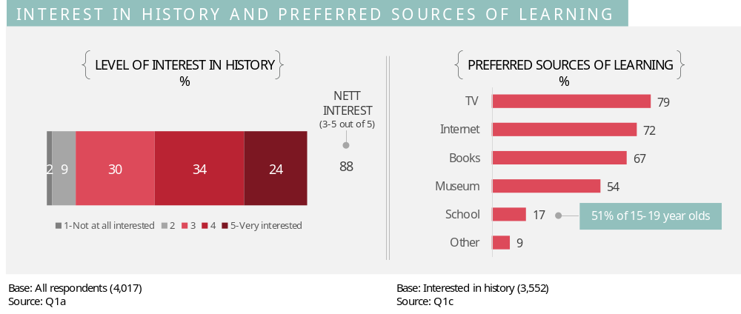
A large majority (88%) of New Zealanders show a reasonable interest (rating of 3, 4, or 5 out of 5) in history. Just over half (58%) show a stronger level of interest (4 or 5 out of 5).
Sources of learning accessible in the home seem to be preferred, with most saying they like to learn about history on TV (79%), or from the Internet (72%) and books (67%). Museums and schools are also important sources of learning about history; 54% like to learn about history at a museum and 51% of school aged New Zealanders (15 to 19 year olds) like to learn about history at school.

Demographic analysis
The chart below summarises the level of stronger interest in history (rating of 4 or 5 out of 5) by age, gender, ethnicity and region.
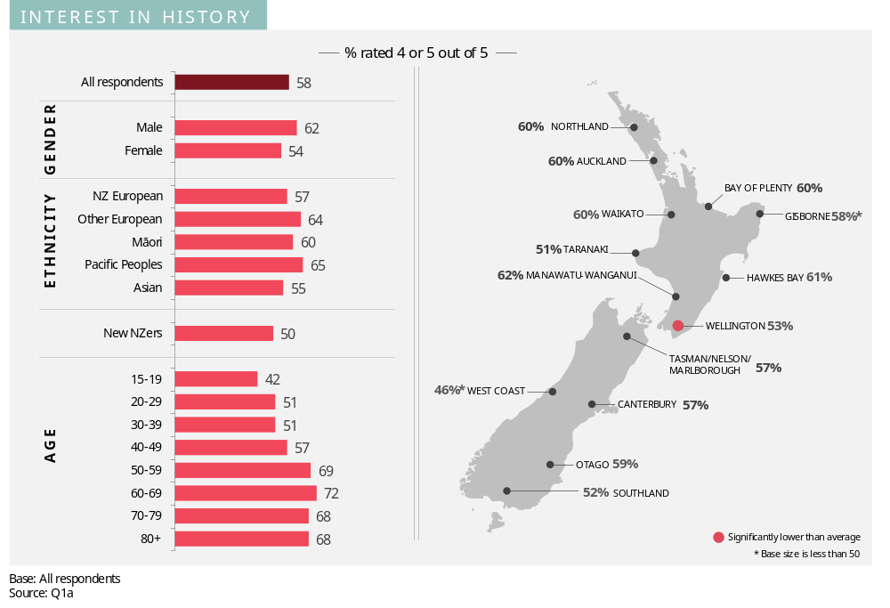Interest in history is higher among males and older age groups. Conversely, interest is lower among ‘new New Zealanders’, females, and younger age groups. There is some regional variation with Wellington residents exhibiting significantly lower interest than on average.
There are also some demographic variations for preferred sources of learning. These are as follows:
- The high proportions of ‘other Europeans’ that like to learn about history from TV and the Internet are comparable with other ethnic groups. However, ‘other Europeans’ are more likely than others to learn about history from books (76% versus 67% of the total sample) and visiting a museum (65% versus 54% of the total sample).
- Asian people show especially strong preferences for learning from the Internet (83% compared to 72% of the total sample) and school (32% compared to 17% of the total sample). A similar pattern is evident among ‘new New Zealanders’.
- Males are more likely than females to learn about history from the Internet (78% versus 68% of females). Conversely, females are more likely than males to learn about history from books (69% versus 64%) and by visiting a museum (57% versus 51%).
- Those aged under 60 years are more likely to learn about history from the Internet than those aged 60 years or more (75% versus 63%).
- Learning about history from a book increases with age.

Local community history
Respondents were asked how interested they are in the history of their local community using a five point scale where 1 is ‘not at all interested’ and 5 is ‘very interested’. Those who rated their interest at least a 3 out of 5 were then asked whether they had undertaken any research, or looked into, the history of their local community.
The results are illustrated below.
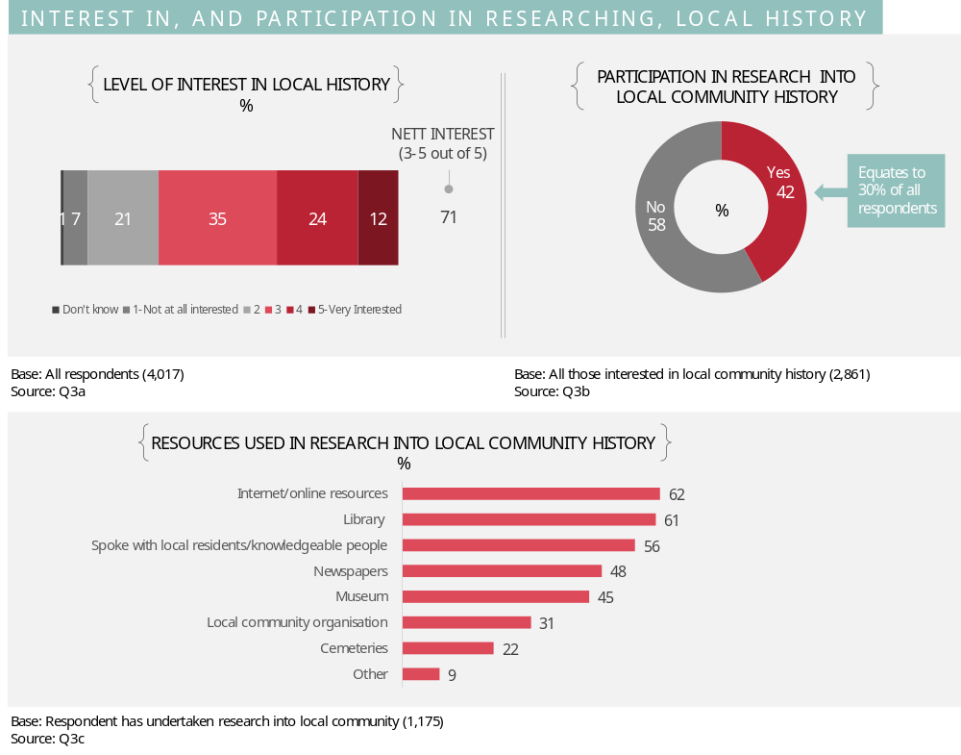Around seven in ten (71%) New Zealanders indicate they have a reasonable interest (3, 4 or 5 out of 5) in the history of their local community. Just over one third (36%) show a stronger level of interest (4 or 5 out of 5).
Of those who are interested in the history of their local community, four in ten (42%) have undertaken research, or looked into, the history of their local community. This equates to 30% of all respondents. A range of resources are utilised, with the Internet (62%), the library (61%) and conversations with local residents or knowledgeable people (56%) being most common.

Demographic analysis
The chart below summarises the level of stronger interest in local history (rating of 4 or 5 out of 5) by age, gender, ethnicity and region.
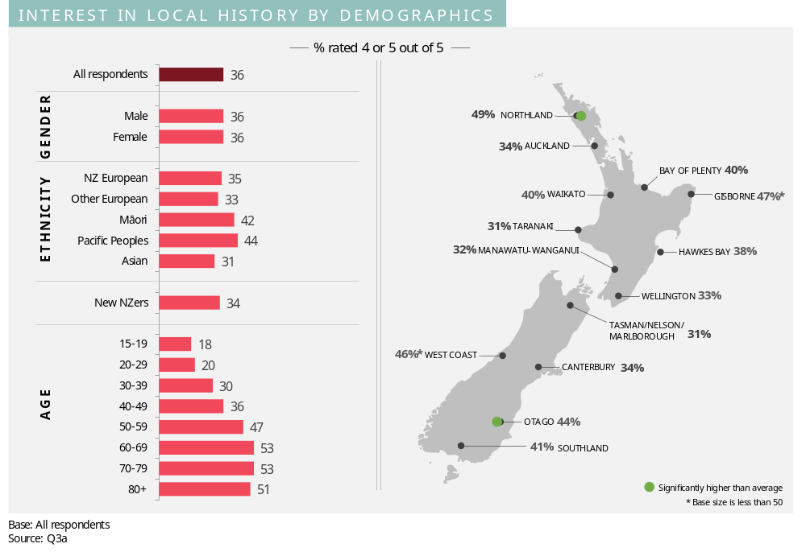
Levels of interest in local history increase with age.
In terms of ethnicity, interest in local history is especially strong among Maori and Pacific peoples. The high interest among Northland and Gisborne residents partly reflects high proportions of Maori in these regions. Otago residents also exhibit a higher than average interest in local history.
Analysis of whether a person has undertaken any research, or looked into, the history of their local community shows similar demographic patterns to those above. A notable exception to this is that whilst Pacific people are more interested in local history than on average, this is not translated into behaviour – they are no more likely to have undertaken any research or looked into the history of their local community.
There are also some demographic variations for preferred sources of learning. These are as follows:
- Maori have a strong preference for speaking with local residents/knowledgeable people (69% versus 56% of total sample)
- Asian people are more likely to source information from the Internet (77% versus 62% of total sample)
- Pacific people have a strong preference for sourcing information from local community organisations (51% versus 31% of total sample)
- Other Europeans are more likely to visit a cemetery to source information (33% versus 22% of total sample)
- Males are more likely than females to source information from the Internet (68% versus 56%)
- Females are more likely than males to visit a cemetery (27% versus 17%).

Genealogy
Respondents were asked how interested they are in family history/genealogy using a five point scale where 1 is ‘not at all interested’ and 5 is ‘very interested’. They were also asked whether they, or someone else in their family, had undertaken any research into their own family history/genealogy. The results are illustrated below.
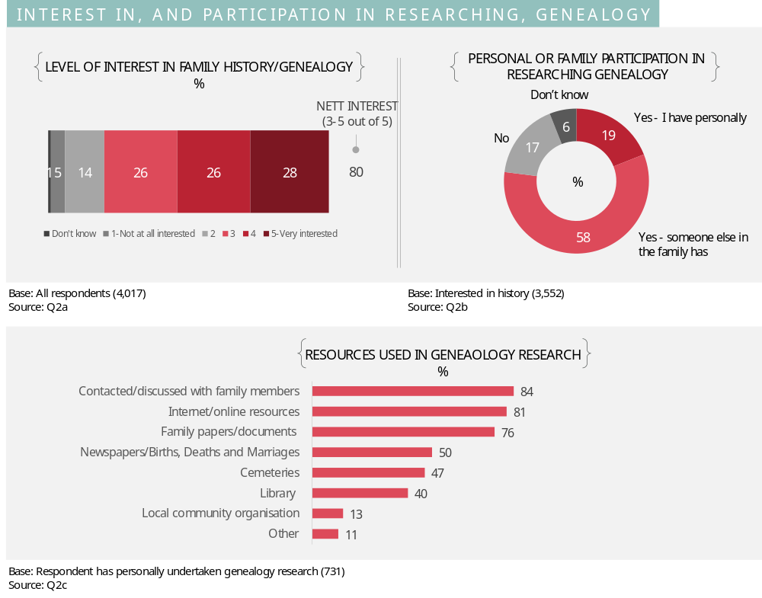
A large majority (80%) of New Zealanders show a reasonable interest (rating of 3, 4, or 5 out of 5) in genealogy. Around half (54%) show a stronger level of interest (4 or 5 out of 5).
Nearly one in five (19%) have personally undertaken research into their family’s genealogy. A further 58% say that someone else in their family has undertaken this type of research.
Contact and conversations with family members (84%), Internet resources (81%) and family papers/documents (76%) are the most common sources used, with more than three quarters having used each of these sources.

Demographic analysis
The chart below summarises the level of stronger interest in genealogy (rating of 4 or 5 out of 5) by age, gender, ethnicity and region.
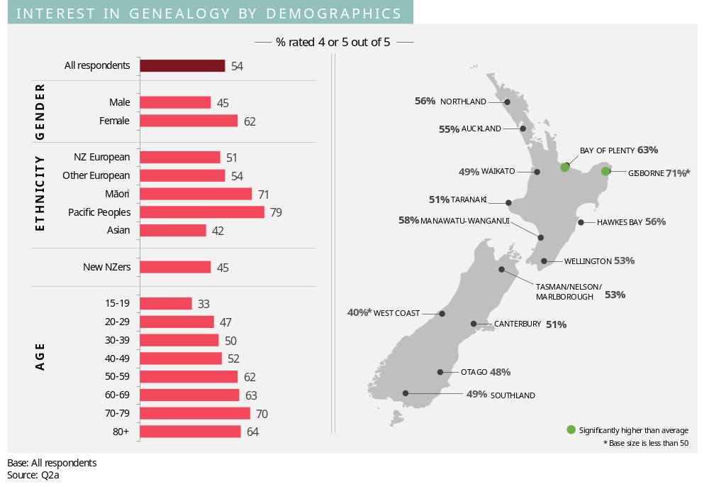There are strong variations by ethnicity with Maori and Pacific people showing especially high levels of interest in genealogy. The strong interest among Maori contributes to the high levels of interest evident among Bay of Plenty and Gisborne residents.
Interest in genealogy is also higher among females and older age groups.
Analysis of whether a person has undertaken any research, or looked into, the history of their genealogy shows similar demographic patterns to those above. A notable exception to this is that whilst Pacific people are more interested in genealogy than on average they are no more likely to have undertaken any research/looked into the their family history.
There are also some demographic variations for preferred sources of learning. These are as follows:
- Females and older age groups are more likely to have used multiple sources than males and younger age groups respectively
- Maori are especially likely to have spoken or written to family members (93% compared to 84% of the total sample), investigated family papers/documents (90% versus 76% of the total sample), and visited a cemetery (60% versus 47% of the total sample).

Relevance of the First World War to New Zealand
This section explores New Zealanders’ perceptions of the relevance of the First World War in shaping New Zealand’s identity. The perceived importance of the Australian relationship to New Zealand’s history is also covered.

Relevance in developing New Zealand’s national identity
Respondents were asked overall how relevant they think the First World War has been in developing New Zealand’s national identity.
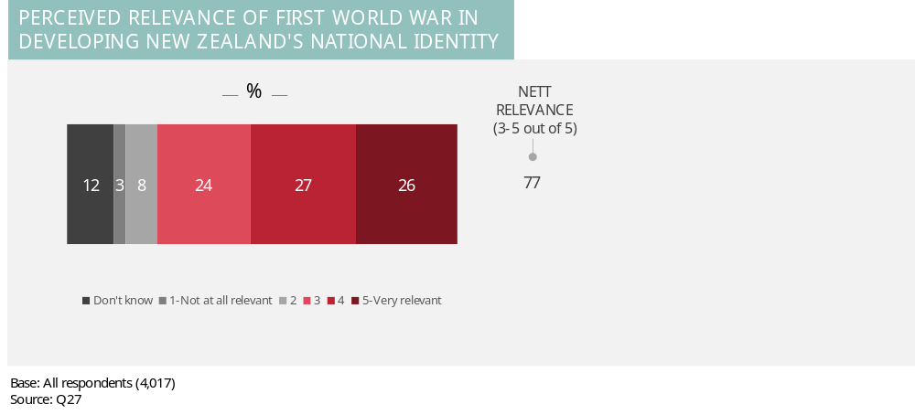
Around three quarters (77%) of New Zealanders think the First World War has some degree of relevance to New Zealand’s national identity (giving a rating of 3, 4 or 5 out of 5). Just over half (53%) view the War as more strongly relevant (rating of 4 or 5 out of 5).

Demographic analysis
The chart below summarises perceptions of the relevance of the First World War in developing New Zealand’s national identity by the various demographic groups.
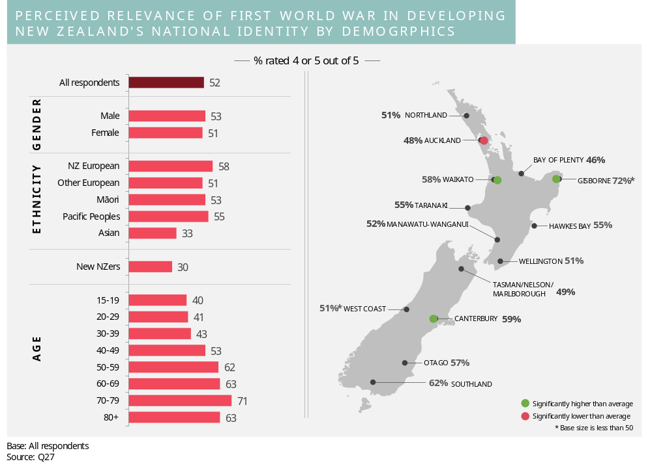New Zealand Europeans are more likely to perceive the War to be relevant, whereas Asian people and ‘new New Zealanders’ are least likely to feel this way. Perceived relevance increases with age. There are also a number of variations by region.

Importance of Australian relationship to New Zealand’s history
Respondents were asked how important they think the Australian relationship is to New Zealand’s history.
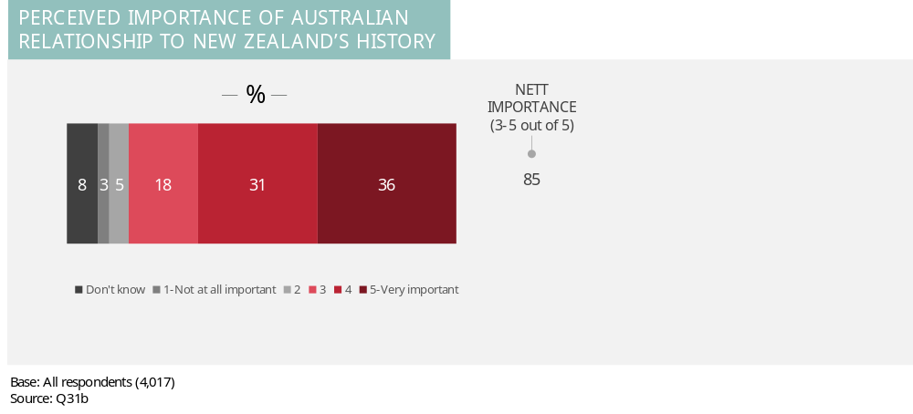
A large majority (85%) of New Zealanders think the Australian relationship is important to New Zealand’s history (rating of 3-5 out of 5), with around two thirds (67%) considering it to be more strongly important (rating of 4 to 5 out of 5).

Demographic analysis
The chart below summarises perceptions of the importance of the Australian relationship to New Zealand’s history by the various demographic groups.
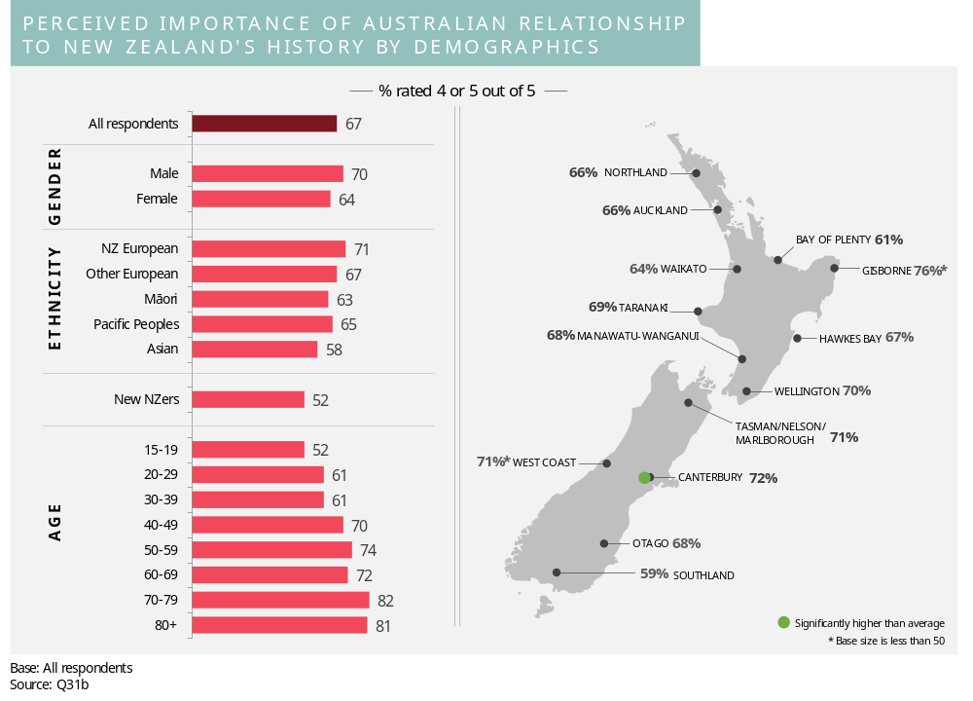New Zealand Europeans are more likely to think that the Australian relationship is important to New Zealand’s history, whereas Asian people and ‘new New Zealanders’ are least likely to feel this way. Males are more likely than females to consider the relationship to be important. Perceived importance also increases with age.

Personal engagement with the First World War
This section describes New Zealanders’ personal engagement with the First World War by looking at the involvement of New Zealanders’ family members in the First World War, perceptions of the relevance of the First World War to our lives today, New Zealanders’ participation in activities related to the First World War, and recall of information about the First World War.

Family involvement in First World War
Respondents were asked whether anyone in their family served or fought in the First World War and, if they had, what the relationship to the respondent was.
Results are presented in the chart below.
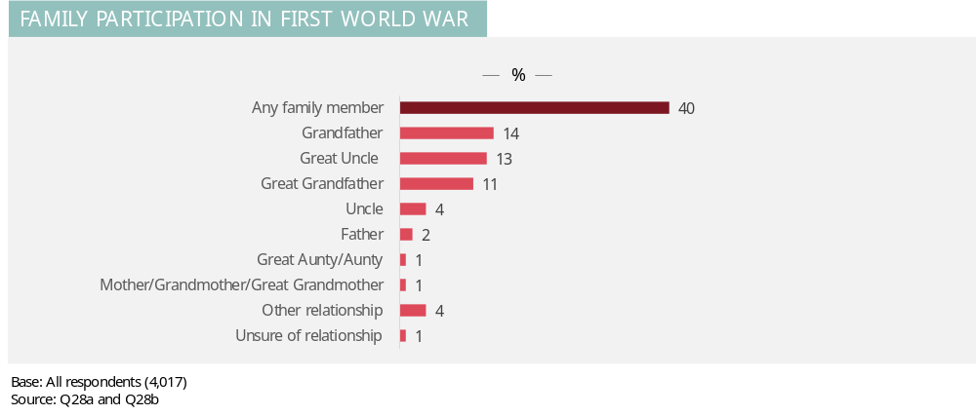
Four in ten (40%) New Zealanders have had a family member who served or fought in the First World War. This is most likely to have been a grandfather (14% of all respondents), great uncle (13%) or great grandfather (11%).

Demographic analysis
The chart below shows the proportions of respondents in various demographic groups with a family member who served or fought in the War.
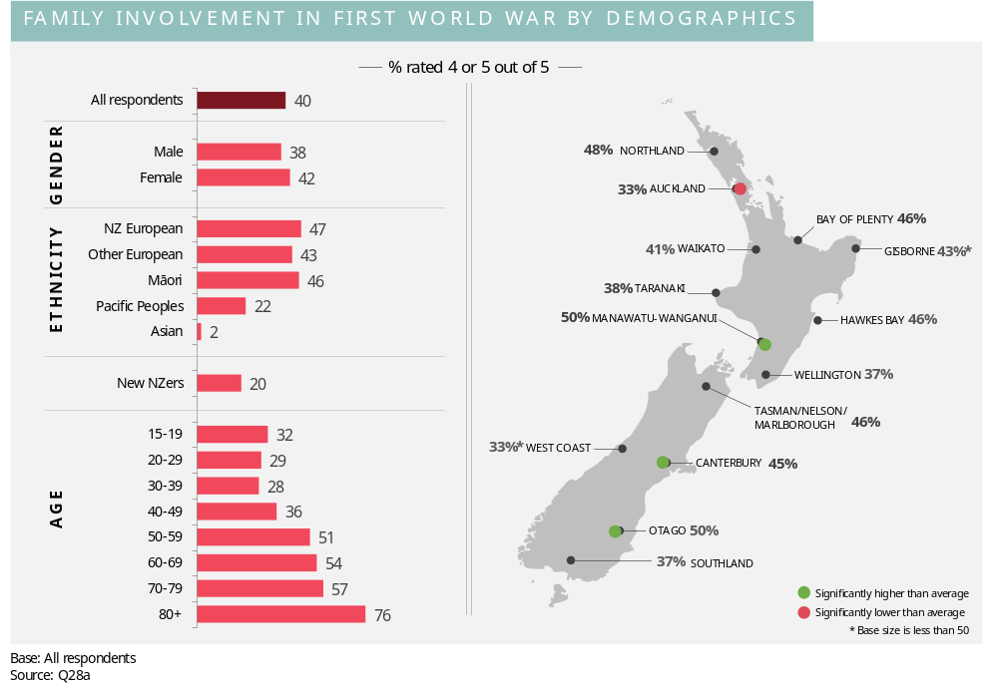As illustrated in the chart, the likelihood of involvement of a family member in the First World War increases with age. There are also strong regional variations. In terms of ethnicity, New Zealand European, ‘other European’ and Maori are more likely to have had a family member involved in the War than Pacific people or Asian people.

Engagement with others about family’s experience in the First World War
Respondents with a family member who served in the First World War were asked whether they have talked to their family or friends about their family’s participation or experience during the First World War.
Results are presented in the chart below.
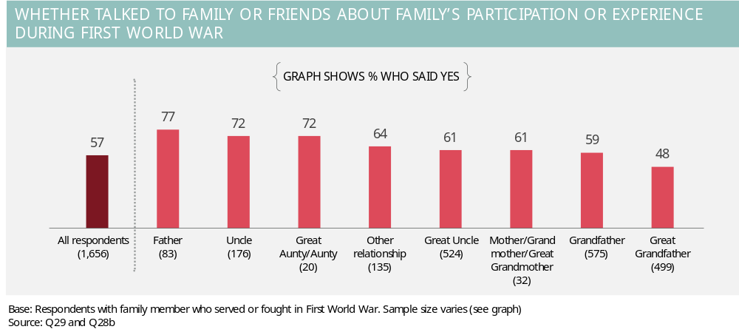
Over half (57%) say they have talked to their family or friends about their family’s participation or experience during the First World War. The graph illustrates that this is more common when the relationship between the respondent and the family member who served is more immediate. For example, people are more likely to have spoken about their family’s experience if the family member who served in the War was a father or uncle rather than a grandfather, great uncle or great grandfather.
Consistent with this finding, demographic analysis shows that the likelihood of talking to family or friends about the family’s participation or experience during the First World War increases strongly with age. Further, New Zealand Europeans (58%) and Pacific people (68%) are more likely than Maori (46%) to have talked to their family or friends.

Interest in finding out more about family’s involvement
Respondents with a family member who served in the First World War were asked if they would like to find out more about their family’s involvement in the First World War given the opportunity.
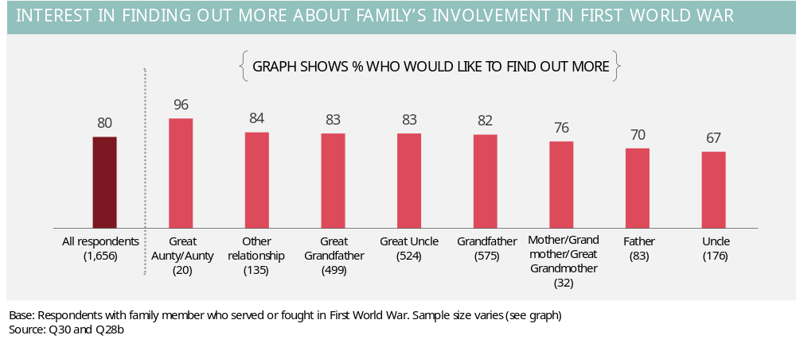
A large majority (80%) indicate that they would like to find out more about their family’s involvement in the First World War. This is more likely to be the case when the relationship between the respondent and the family member who served is more distant. For example, interest is more common if the family member who served in the War was a great grandfather, great uncle or grandfather rather than an uncle or father.
Demographic analysis shows that those aged less than 70 years are more likely than those aged 70 years or more to express an interest in finding out more information (82% and 70% respectively). Hawkes Bay residents are most likely to be interested in finding out more information (91% compared to 80% of the total sample).

Personal relevance of the First World War
Respondents were asked how relevant what happened in the First World War, and the outcome of the War, is to their life today. A five point scale was used where 1 is not at all relevant and 5 is very relevant.
Results are presented in the chart below.
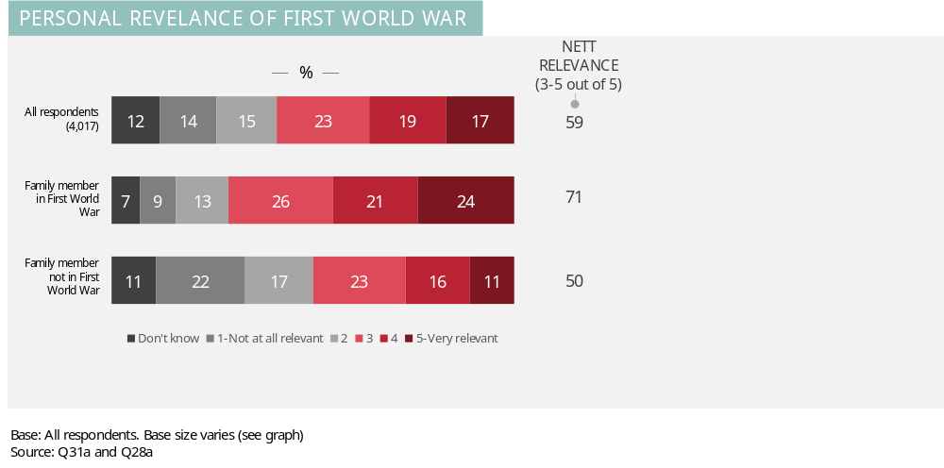

Over half (59%) of New Zealanders perceive the First World War to be at least somewhat relevant to their life today (rating of 3-5 out of 5). Whether or not a person has had a family member who served or fought in the First World War has a strong bearing on the results, with 71% of those who have regarding the War as personally relevant compared to only 50% among those who have not.

Demographic analysis
The chart below shows perceptions of relevance of the War for various demographic groups.
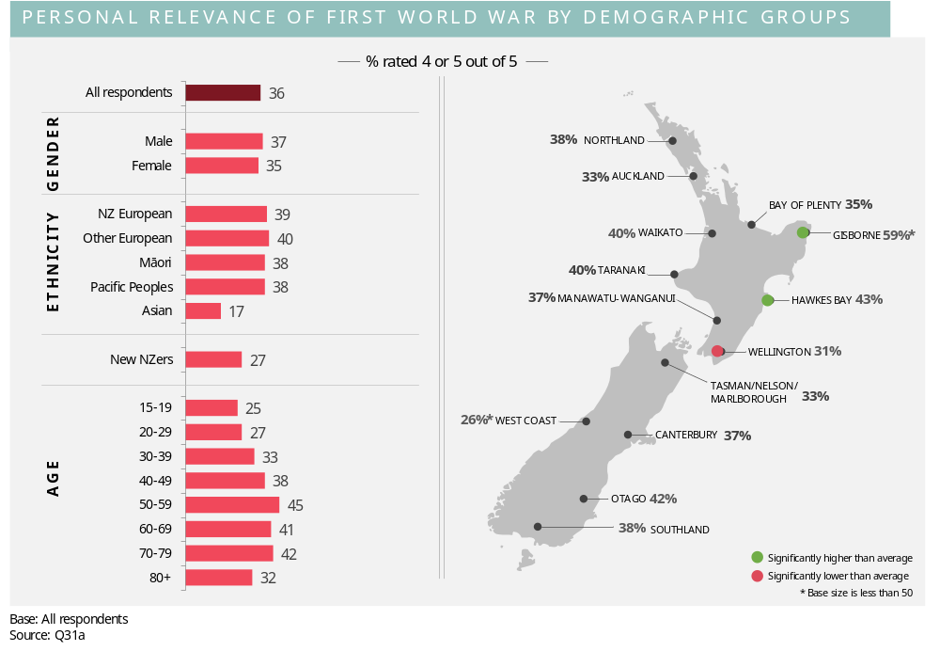
Whilst there is little variation by gender and ethnicity (with the exception of Asian people), perceived relevance increases strongly with age (up until age 70-79) and there are a number of regional variations.

Participation in First World War activities
Respondents were shown a list of various activities related to the First World War and asked which they had done. The chart below shows the proportions of New Zealanders who have taken part in each activity.
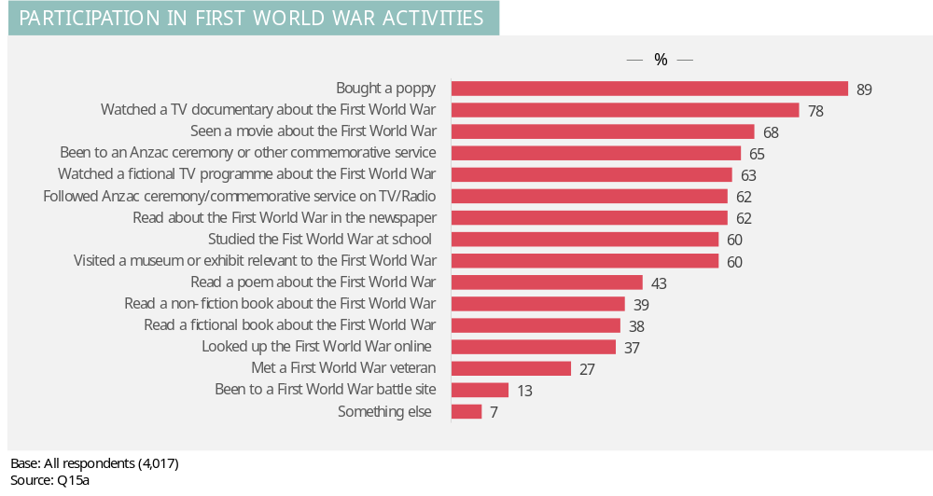
Buying a poppy is the most common way New Zealanders’ have engaged in activities related to the First World War (89%). Watching visual footage/coverage about the First World War is among the other most common activities (78% have watched a TV programme, 68% have seen a movie, 63% have watched a fictional programme and 62% have followed a commemorative service through the media). Attending events is also common with 65% having been to an Anzac/commemorative service and 63% having visited a relevant museum exhibit.
Additional analysis shows that of the 16 activities listed in the questionnaire, just 3% have not taken part in any of the activities, 6% have taken part in 1-2 activities, 16% have taken part in 3-5 activities, 46% have taken part in 6-10 activities and 29% have taken part in more than 10 activities.
On average, New Zealanders have participated in 8.1 activities.

Demographic analysis
The follow chart shows the average number of activities that New Zealanders have participated in for various demographic groups.
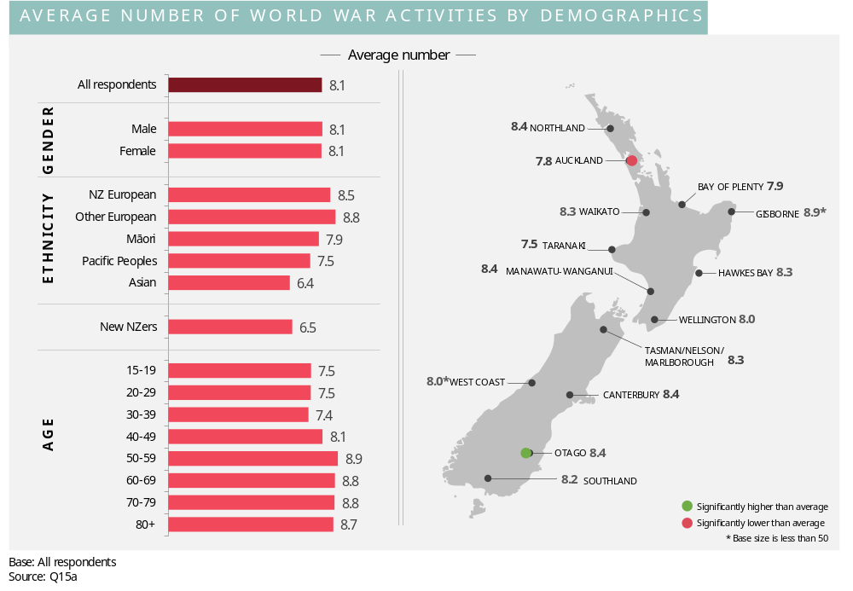Whilst there are not marked variations across the demographic groups, the survey results show that New Zealand Europeans, ‘other Europeans’, and those aged over 40 years tend to have taken part in a higher number of activities.

Recall of recent mention of First World War
Respondents were asked whether they had seen or heard the First World War mentioned in the last three months. Results are shown in the graph below.
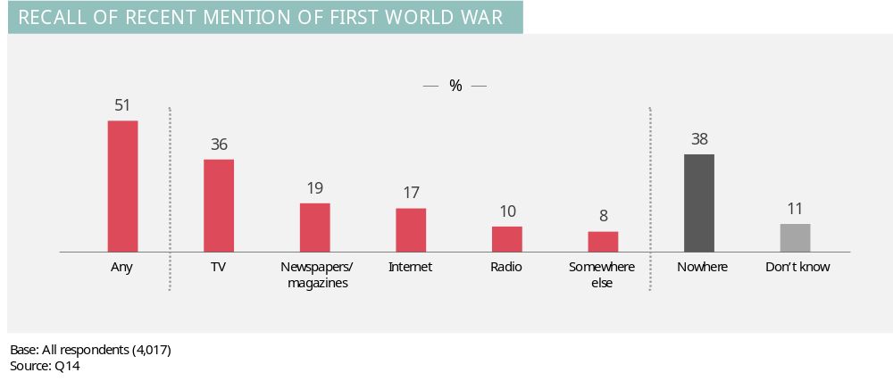
Around one half (51%) of New Zealanders recall at least one channel through which the First World War was mentioned. Television is the most common channel for information on the First World War (36%) followed by newspapers/magazines (19%), the Internet (17%) and radio (10%).
Demographic variations include:
- Recall of any mention is higher among older age groups (70% of those aged 60 years or over), males (54% compared to 49% of females), and ‘other Europeans’ (especially compared to only 43% of Asian people)
- Recall of TV is higher among ‘other Europeans’ (43%), older age groups (49% of those aged 50 years plus), and Cantabrians (41%)
- Recall of newspapers/magazines is higher among those aged 60 years or more (36%)
- Recall of radio is higher among older age groups (15% of those aged 50 years or more).

Top of mind associations
This section describes New Zealanders’ top of mind thoughts about the First World War.
As noted earlier, the questionnaire included a number of open-ended questions. The responses to these questions are being coded as a separate exercise to this report. However, this section presents the results to two of the open-ended questions in the form of ‘word clouds’. A word cloud highlights the key words or phrases used by respondents in answering a question. The larger the word or phrase, the more commonly it was mentioned.

Top of mind associations with the First World War
Respondents were asked what words come to mind when they hear the words, the First World War. The word cloud illustrated below shows that Gallipoli, trenches, death and Anzac feature prominently.
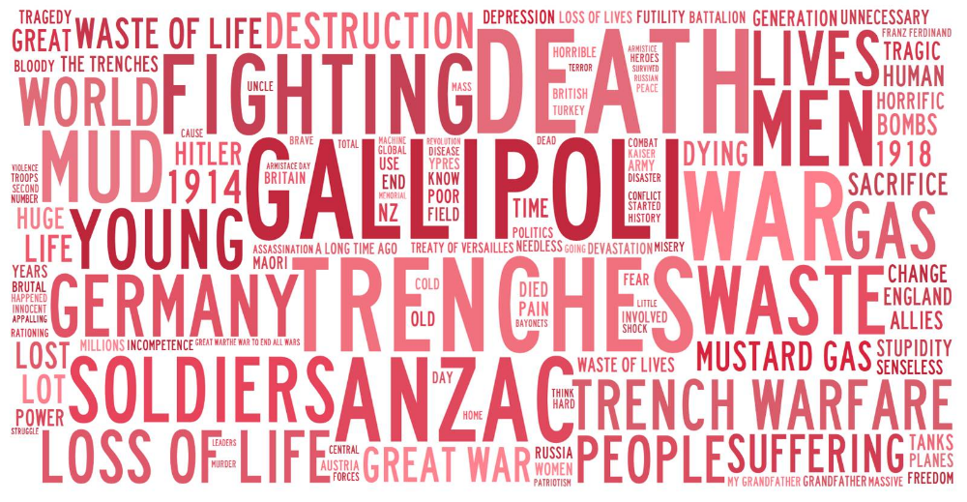
A sample of the comments that were made are provided below.
“My grandfather who had his 21st birthday serving in the front line. He lied about his age to go to war.”
“A terrible waste of life for very little gain. In NZ, whole communities and families were wiped out changing our nation forever. But it's great we have days like Anzac Day so today's generation of children become aware of the wastefulness of war.”
“Horror. It was an awful time for the world and I lost uncles in that war. I was too young to know too much about it but had family that fought and an Aunt that was a nurse and I grew up with tales of the hardship and conditions they lived in.”
“I think of my Granddad and the awful conditions soldiers faced.”

“ANZAC, Gallipoli, battles on Western Front. An appalling loss of life due to inept leadership on both sides. The effect class system had on the war and its aftermath. Ridiculous retribution imposed on Germany which effectively led to the Second World War.”
“Bloody battle that went beyond two countries and involved citizens from around the world to fight for independence and democracy.”
“Unnecessary death of thousands on Kiwis fighting someone else's war.”
“Gallipoli because my father was there. Devastating losses for all countries, especially New Zealand.”
“It was known as the Great War. I think of manual weapons, swords, guns etc. Lots of personal contact, fighting, soldiers dying due to bad health, transportation of medical supplies etc. War on a larger scale than ever seen before. Women going into employment for the first time in ages.”
“Horrible waste of human life in the trenches.”
“Disaster. An enormous waste of life and badly managed by those in charge. Carnage that had never been seen before and should not have been repeated 21 years later.”
“Gallipoli and the unnecessary loss of life in very terrible conditions.”
“My grandfather's experiences as a POW with the Germans and how these experiences had a major (negative) influence on him for the rest of his life. Expanding this view I got from my grandfather is the poetry that I studied at school regarding the brutality of war as experienced by those in WW1.”
“Horror at what took place on the front line and waste of a generation of youth.”
“It was a very bloody war. Many people were killed. It was one of the worst, largest wars in history. During it many New Zealand (ANZAC) soldiers were killed at Gallipoli and New Zealanders remember this event every year on Anzac Day.”
“Killing. A lot of lives got taken and many families lost loved ones.”
“Men who were boys but became men.”
“Sacrifice and distress for families whose children never returned. Prisoners of war - my Uncle.”

Top of mind associations with New Zealand’s involvement in the First World War
Respondents were asked what thoughts come to mind when they think about New Zealand’s involvement in the First World War. The most prominent words are illustrated below. Gallipoli features especially strongly.
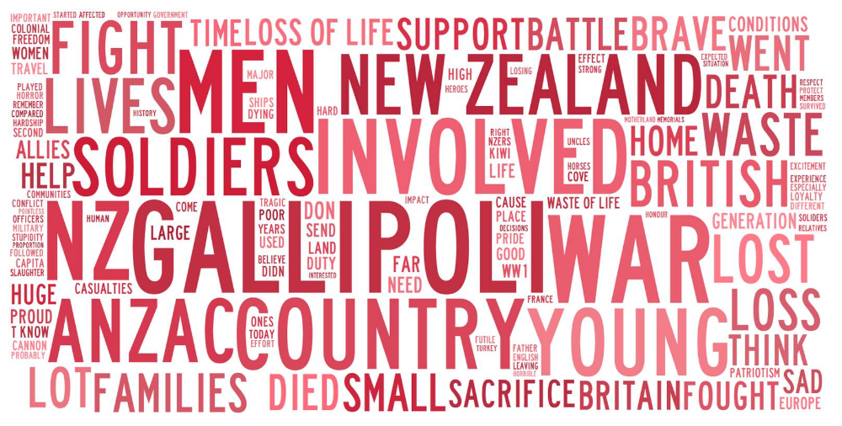
A sample of the comments that were made is provided below.
“A big commitment for a little country.”
“I am originally from England, but learned about the ANZACs and their contribution at school. However, I wonder how NZ and its people must have struggled with fighting a war so far away which must have seemed to have such little relation to their lives over here. I think about the waste of so many young lives for a country itself so young and sparsely populated, and how that continues to affect the NZ of today. I also think it is crucial that young Kiwis are taught about both wars.”
“A call to action for our country. A necessary evil that our country must be part of. Young soldiers fighting for what our country believes in.”
“A duty to the Crown and the Commonwealth. Such a large proportion of Kiwi men went to fight and defend Gallipoli.”
“I believe that most New Zealanders at the time were not really aware of what the First World War was and what it involved. The men that left to go and fight were misled. And later those New Zealand and Australian divisions were inadequately commanded.”
“I think of young men and women who had never been off their respective island let alone travelled overseas and how terrifying the first experience of trench warfare must have been for them, seeing their friends die from wounds, disease, and sheer fright.”
“My first thoughts are always Gallipoli because of New Zealand’s involvement in WW1. The country grew up somewhat and the first steps towards becoming less dependent on Britain began.”
“A huge loss of young NZ men in horrible condition. They were led by British officers who used them as cannon fodder and were poor leaders.”
“A significant proportion of the population were involved, and made a significant contribution at great cost of life. Their experiences are unimaginable today.”
“ANZAC Day. The parades. People buying and selling poppies. My family and I going to the cemetery to see my great grandfather’s plot in the soldiers area.”
“How many troops were sent. The different divisions and regiments. How New Zealand troops were thought of in comparison to the other countries' soldiers. The major battles they fought in, such as at Gallipoli. The frame of mind they had when signing up to fight.”
“How patriotic it was to a country so far away. How it affected every part of New Zealand. What a waste of the youth of the country.”
“ANZACs and Gallipoli is the main one I think about, but know there were many more battles.”
“ANZAC debacle caused by inept British military leadership. High casualty rates per head of population compared to other countries. Ettie Rout's great work and the outrageous stupidity of those who opposed her. How many more awful events (e.g. Depression and WW2) were still to come for soldiers and families who had endured the horrors of WW1. The value of maintaining the war graves for New Zealanders in Europe so well - had a profound effect on me when I visited in my early 20s.”
“Brave men and women who went to fight for their country knowing that they might not return. They were gone for very long periods of time, travelled by boat to get to Europe. They fought bravely in the trenches with primitive supplies.”
“Gallipoli and the effect this had on New Zealanders and young Kiwi's travelling to the site today gives everyone some perspective.”
“I believe NZ became involved in WW1 because of our historic and cultural links with 'Mother England'. I am not sure that our involvement was fully appreciated. We were cannon fodder. It represented a terrible loss of life and must have impacted on most families here in NZ in some way or other.”
“My grandfather was gassed in this war and was invalided all the rest of his life. He told us stories but never the tragedy of his experiences. I always am reminded of those who never came back to families and loved ones.”
“One of the highest per capita death rates of any country in the war. The great deeds of the Maori Battalion. The effect the war had on the soldiers returning to NZ.”

Knowledge of the First World War
This section examines different aspects of New Zealanders’ knowledge of the First World War.

Self-reported knowledge of the First World War
Respondents were presented with a list of statements and asked to select the one that best described how much they know about New Zealand’s involvement in the First World War. Results are presented in the chart below.
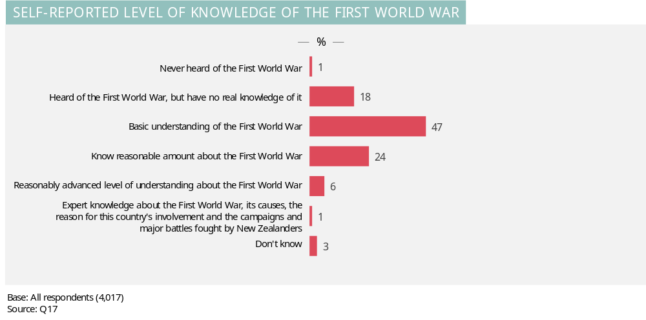Nearly one half (47%) of New Zealanders describe their understanding of the First World War as basic. Almost one in five (19%) indicate they have no real knowledge of the First World War or have never heard of it (this includes just 1% who have never heard of the War). Conversely, nearly one third (31%) indicate they have more than a basic understanding.

Demographic patterns
The following four charts assess levels of self-reported knowledge by gender, age, education, ethnicity and region. For ease of analysis, the response categories have been grouped into:
- Less than basic understanding (never heard of First World War or heard of it, but have no real knowledge of it)
- Basic understanding (basic understanding of the First World War)
- More than basic understanding (know reasonable amount, reasonably advance level of understanding, and expert knowledge).

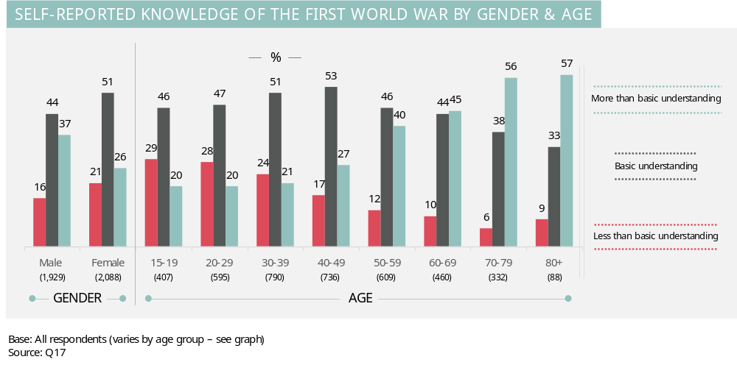

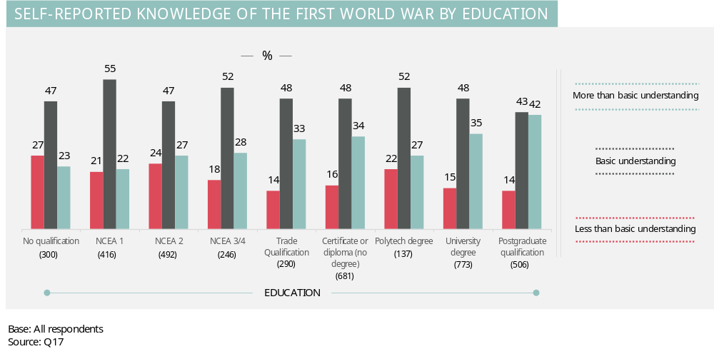
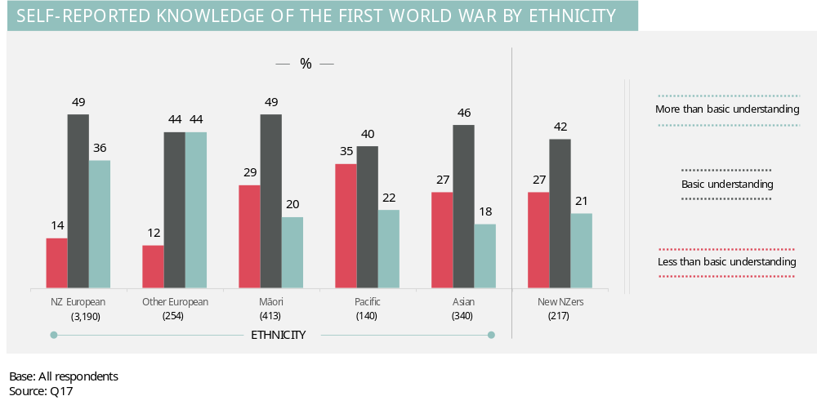

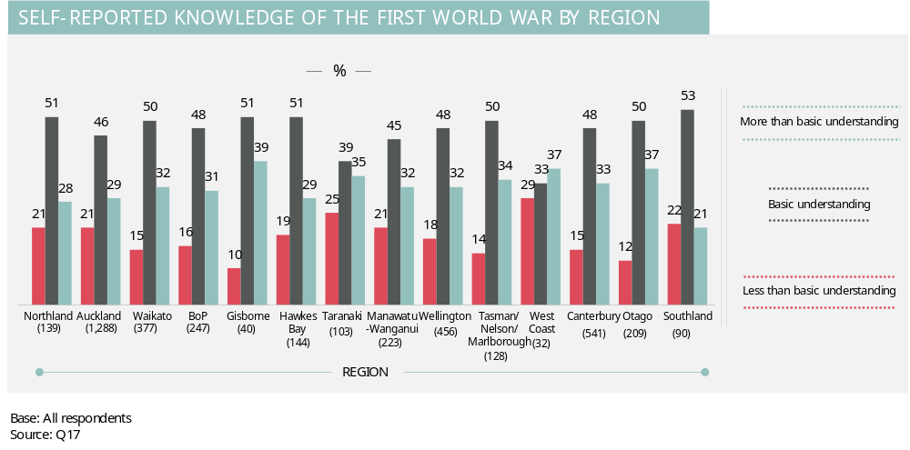
Levels of self-reported knowledge of the First World War are higher among males, older age groups, more highly educated people, New Zealand Europeans, and ‘other Europeans’. Conversely, self-reported knowledge is lower among females, younger people, those with lower education qualifications, as well as ‘new New Zealanders’, Maori, Pacific, and Asian peoples.
There is little statistically significant variation in self-reported knowledge of the First World War by region. Otago residents have somewhat higher self-reported knowledge, with 87% having at least a basic understanding compared to 78% of the total sample.

Knowledge of meaning of Anzac acronym
Respondents were asked what the term Anzac stands for. They were shown four different possibilities as illustrated in the graph below.
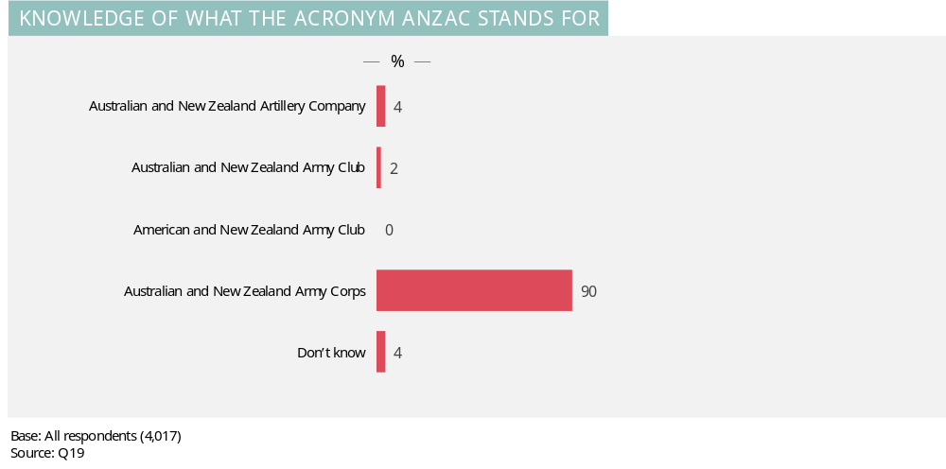
A very large majority (90%) correctly understand that Anzac is an acronym for Australian and New Zealand Army Corps.

Demographic analysis
The chart below shows knowledge of the Anzac term across the various demographic groups.
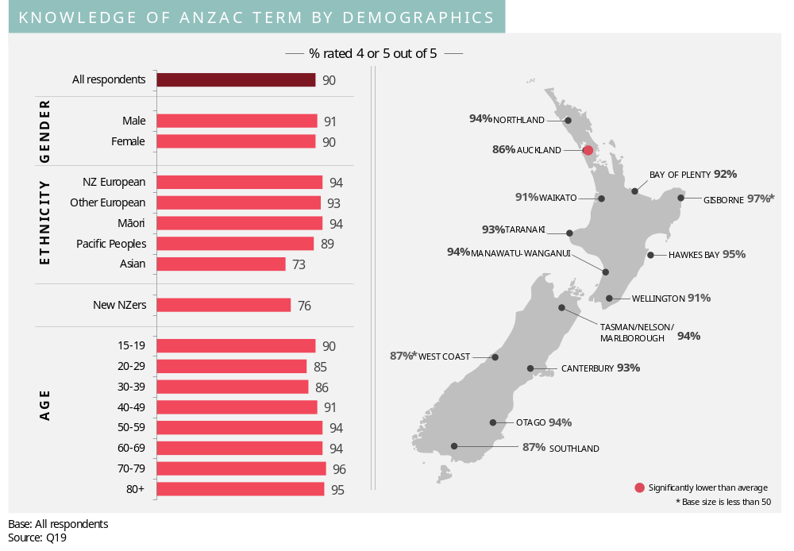
Whilst knowledge of the Anzac term is high across all demographic groups, it is notably lower among Asian people and ‘new New Zealanders’. It is also somewhat lower among the 20-39 year age group and Aucklanders.

Awareness of New Zealand’s occupation in Samoa
Respondents were asked whether they knew that New Zealand occupied Samoa in the First World War.
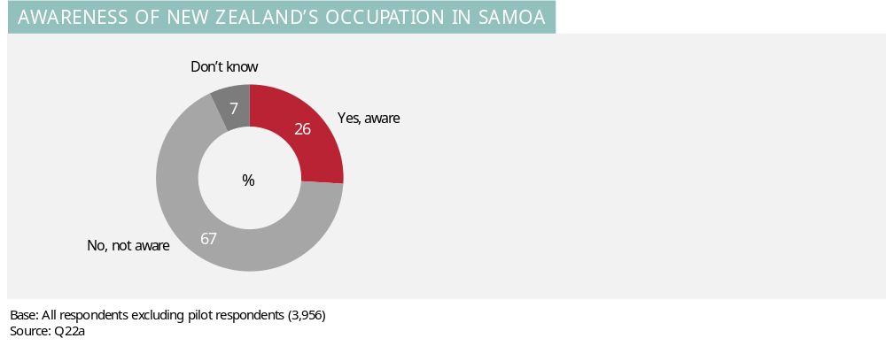
One quarter (26%) of New Zealanders are aware that New Zealand occupied Samoa in the First World War.

Demographic analysis
The following chart shows knowledge of New Zealand’s occupation of Samoa across the various demographic groups.
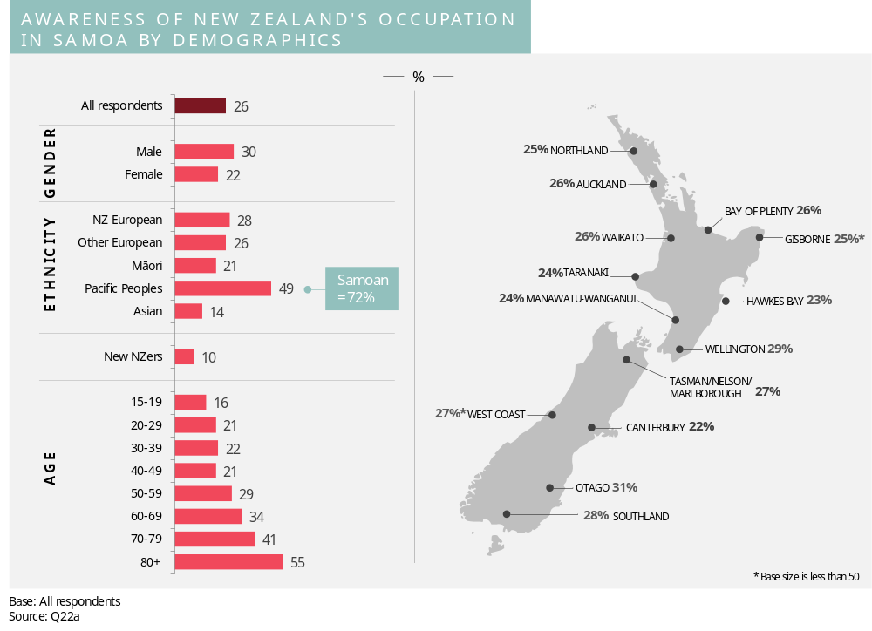Knowledge is higher among Pacific peoples and is especially high among Samoan people (72%). Knowledge is also higher among males than females, and correlates positively with age.

Awareness of First World War start and end dates
Respondents were asked in what year the First World War began and in what year the First World War ended.
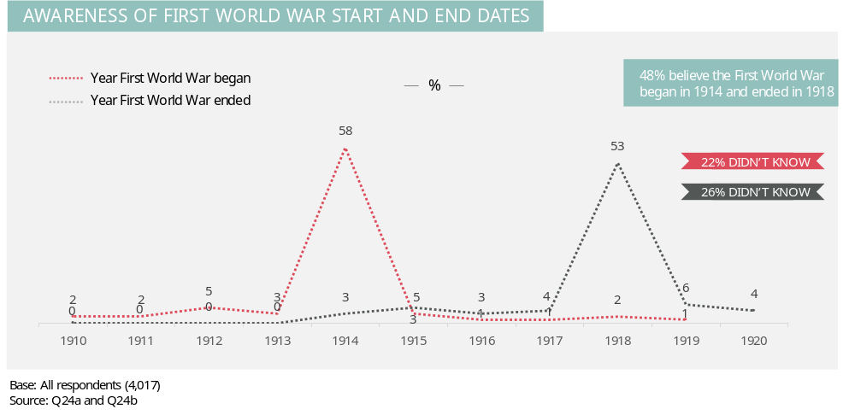
Proportions of just over half know the beginning and end dates (58% and 53% respectively). Nearly half (48%) know both dates.

Demographic analysis
The following chart presents the proportions of people in various demographic groups who know both the beginning and end dates of the First World War.
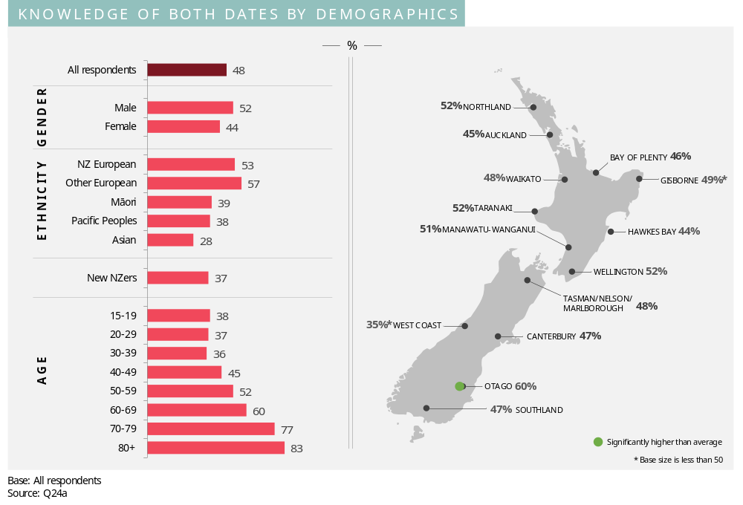Demographic analysis shows that knowledge of both the beginning and end dates of the First World War is higher among New Zealand Europeans and ‘other Europeans’ than other ethnic groups. Likewise, knowledge is higher among males than females, and correlates positively with age. Otago residents also exhibit higher than average understanding of the dates.

Awareness of First World War fronts and battles
Respondents were shown a list of fronts and battles and asked which they were aware of. They were then asked to identify the most important battle of the First World War for New Zealanders.
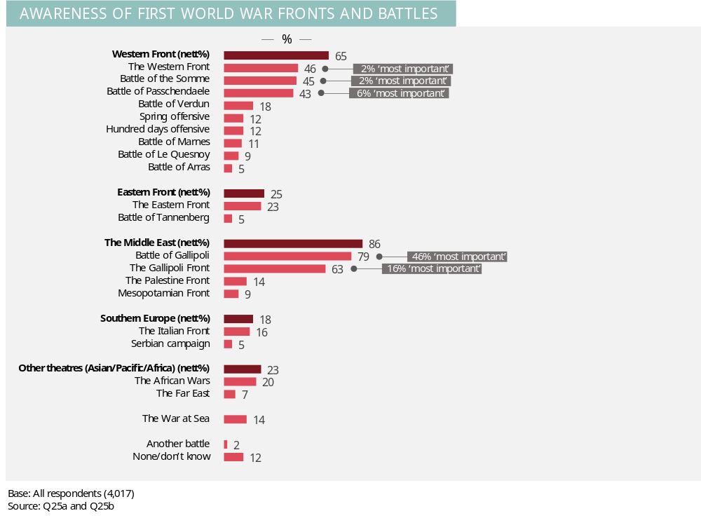
The Battle of Gallipoli and the Gallipoli Front (79% and 63% respectively) are most well known, with the Western Front (46%), the Battle of the Somme (45%), and the Battle of Passchendaele (43%) also receiving notable recall.
Additional analysis shows that 12% of New Zealanders do not know any battles/fronts, 12% know of one, 23% know of two or three, 19% know of four or five, and 35% know of more than five.
By a substantial margin, Gallipoli is considered to be the most important battle for New Zealanders with nearly two thirds (62%) choosing either the Battle of Gallipoli or the Gallipoli Front.

Demographic analysis
The chart below shows the average number of fronts/battles for the various demographic groups.
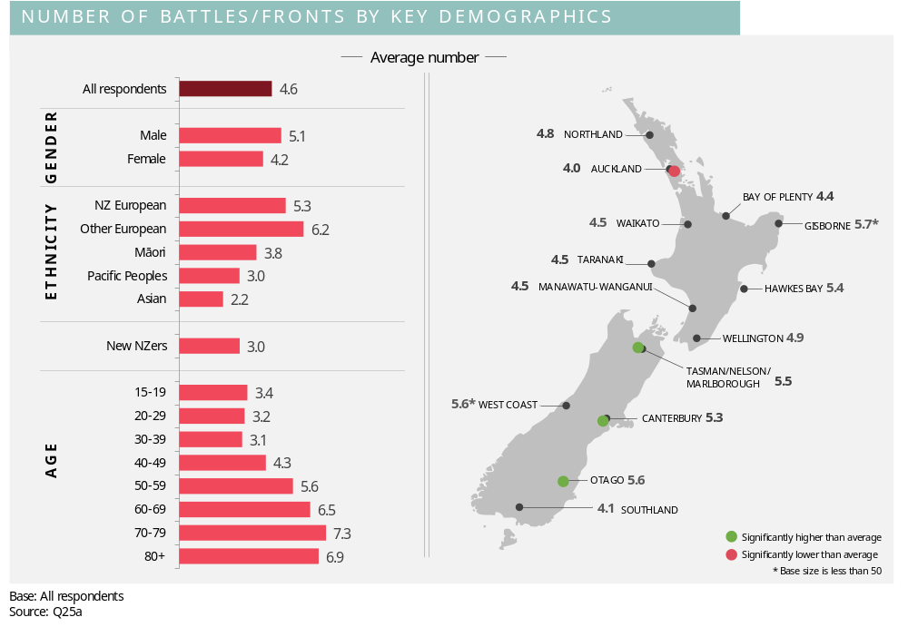
On average, New Zealand Europeans and other Europeans know about more battles than other ethnic groups. Likewise, males’ knowledge is higher than females. Knowledge of battles and fronts is positively correlated with age.

Perceptions of where more New Zealanders were killed
Respondents were asked whether more New Zealanders were killed in Gallipoli or the Western Front.
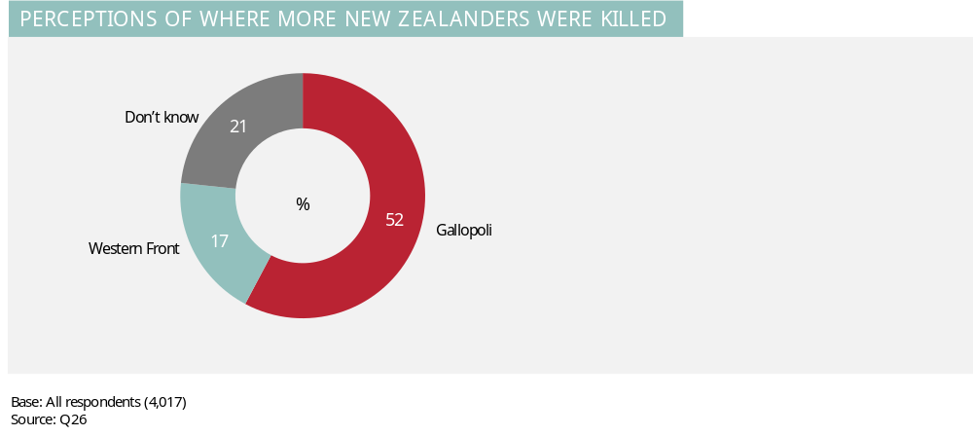
Despite the Western Front battles being the deadliest in New Zealand’s military history, it is considerably more common for people to believe that more New Zealanders were killed in Gallipoli (52% compared to only 17% for the Western Front). Around one in five indicated they were unsure (21%).

Demographic analysis
The chart below shows the correct knowledge of the Western front by the various demographic groups.
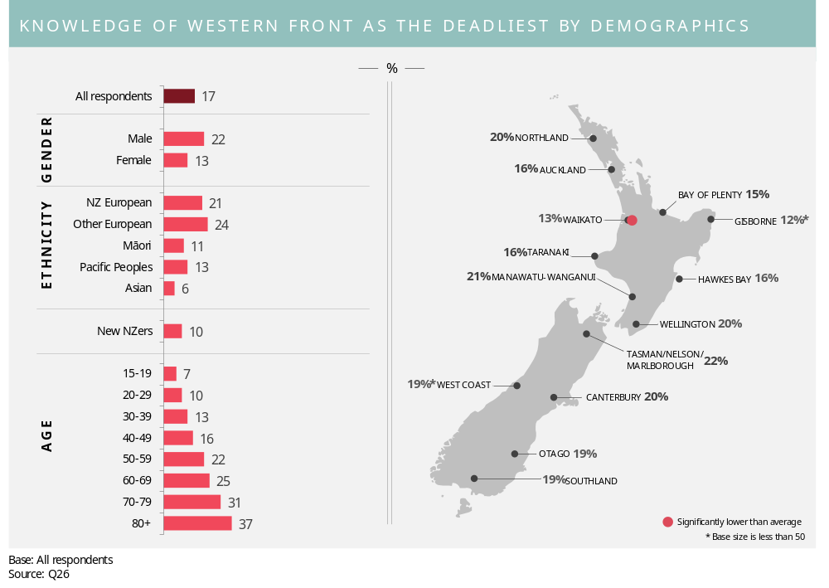
Knowledge is higher among males, New Zealand Europeans, and ‘other Europeans’, and older age groups.

First World War commemorations
This section examines New Zealanders’ awareness and interest in First World War commemorations.

Perceived importance of First World War commemorations
Respondents were asked how important they think it is for New Zealand to commemorate the centenary of the First World War. Results are shown in the graph below.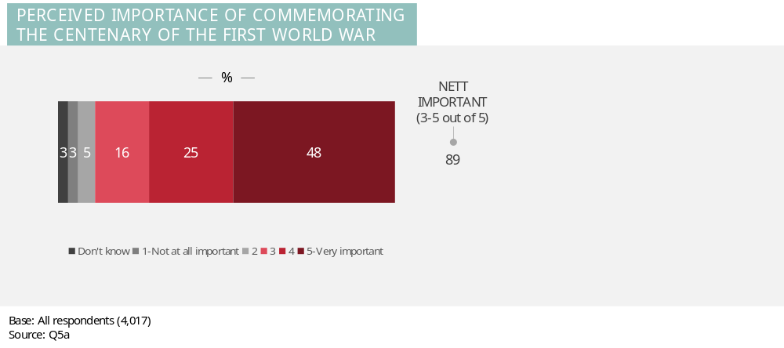
Commemorating the centenary of the First World War is considered to be important by a large majority of New Zealanders (89%). Nearly half (48%) consider this to be very important (5 out of 5).

Demographic analysis
The chart below shows the level of relatively high importance (rating of 4 or 5 out of 5) for each of the key demographic groups.
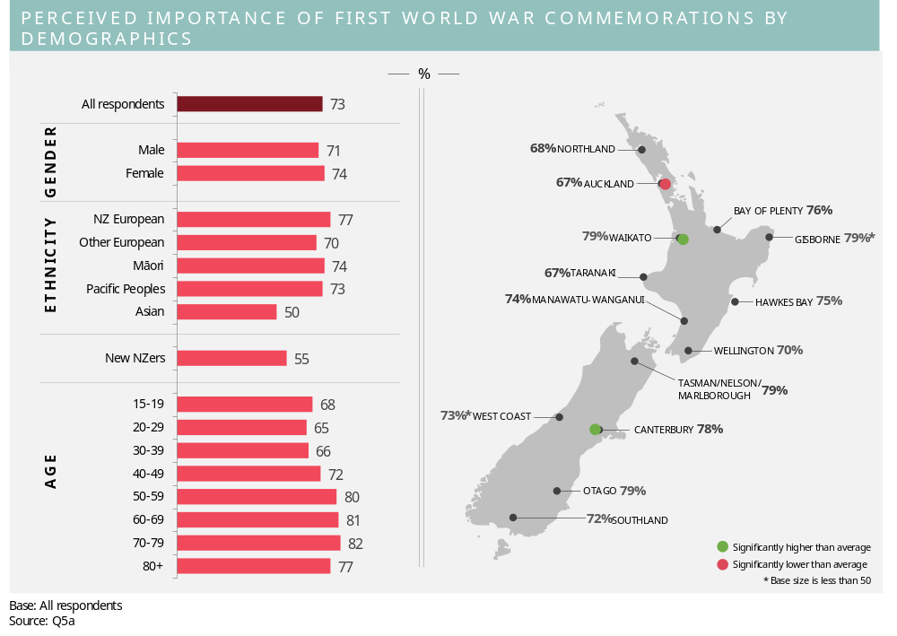There are good levels of support for commemorating the First World War across all demographic groups. However, New Zealand Europeans and older age groups feel the commemorations are especially important. Conversely, Asian people, ‘new New Zealanders’ and younger age groups place less importance on the commemorations.
There are several significant variations by region, with Aucklanders placing lower importance on the commemorations. The support shown by Canterbury and Waikato residents is significantly higher than average.

Awareness of Government funding of First World War commemorations
Respondents were asked whether they were aware that the Government will be funding some projects to commemorate the First World War. Those who were aware were then shown a list of projects and asked which they were aware of.
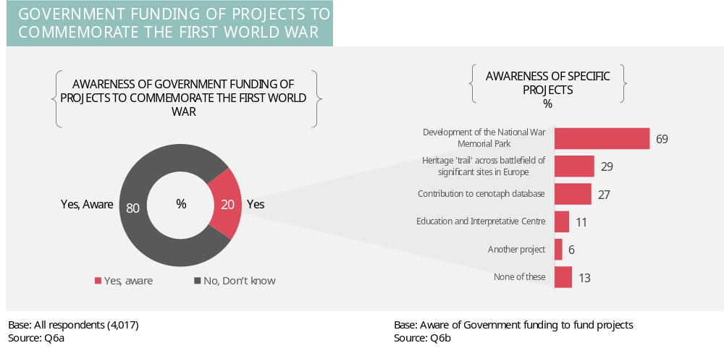
Just one in five (20%) New Zealanders know that the Government is funding projects to commemorate the centenary of the First World War. Awareness is highest for the development of the National War Memorial Park (69% of those aware of government funding to commemorate the centenary are aware of this project).

Demographic analysis
The chart below shows the level of awareness of Government funding projects to commemorate the First World War for the various demographic groups.
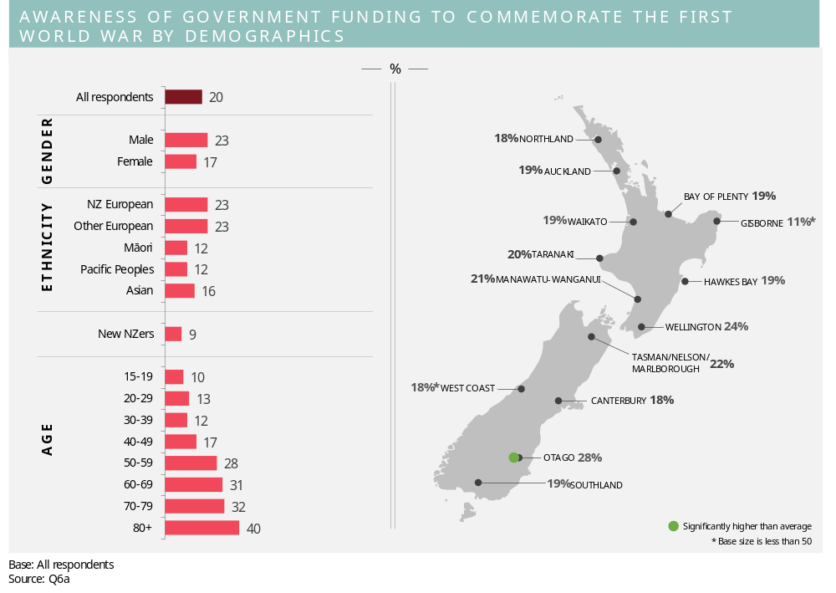Awareness of funding is higher among New Zealand Europeans, males and older age groups. Otago residents are also especially likely to be aware of the funding.

Lottery grants board funding
Respondents were asked if they are aware that the Lottery Grants Board has funding available for community projects to commemorate the First World War. They were also asked if they, or a group they belong to, would consider organising something to commemorate the First World War. Results to these two questions are provided below.
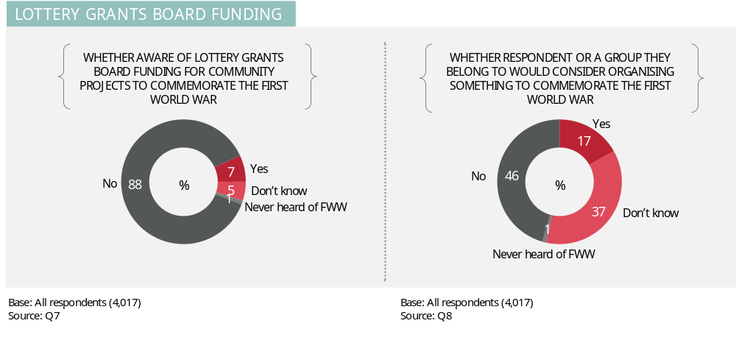
Very few (7%) are aware of the Lottery Grants Board funding for community projects to commemorate the First World War. However, more than double that proportion (17%) say they, or a group they belong to, would consider organising something to commemorate the First World War.

Demographic analysis
There is relatively little variation in awareness of the lottery grants board funding across the demographic groups. However, there are some demographic differences in the proportion who would consider (either themselves or as a part of a group) organising something to commemorate the First World War. This is illustrated below.
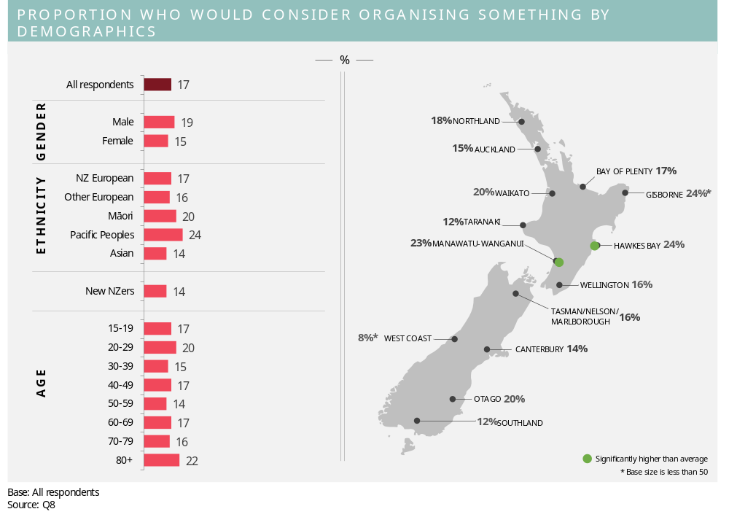Maori, Pacific people, males, 20-29 year olds are most likely to consider organising something. Those living in the Hawkes Bay and the Manawatu-Wanganui region also show relatively high levels of interest.

Likelihood of attending centenary events
Respondents were shown a list of centenary events related to the First World War and asked how likely or unlikely they would be to attend each event if it were made available. They were informed that the events would be held over the next four years. A five point scale was used from 1 to 5 where 1 is ‘very unlikely’ and 5 is ‘very likely’.
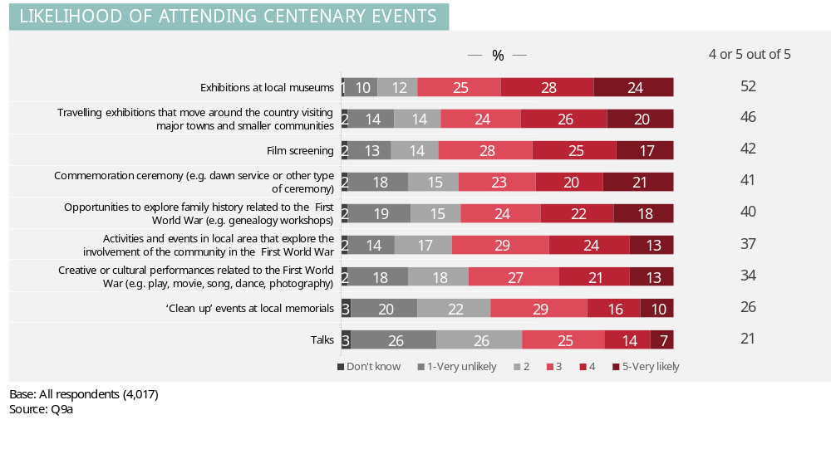Perceived likelihood of attending centenary events is highest for exhibitions (at local museums and travelling exhibitions), film screenings and commemoration ceremonies, with around one in five or more people indicating they are ‘very likely’ to attend these events.

Demographic analysis
For each centenary event, the table below summaries the demographic differences that are apparent in the proportion of respondents who said they are ‘very likely’ to attend.

Event | Total sample result | Demographic groups where there is higher likelihood of attending
Exhibitions at local museums | 24% | - 40 years plus (29% versus 18% of those aged under 40 years)  - Females (26% versus 21% of males).
Commemoration ceremony (e.g. dawn service or other type of ceremony) | 21% | - Increases with age (17% of 15-29 years olds, 22% of 30-79 year olds and 30% of those aged 80 years plus)  - Manawatu-Wanganui region (29%) and Otago (27%).
Travelling exhibitions that move around the country visiting major towns and smaller communities | 20% | - 40 years plus (26% versus 13% of those aged under 40 years)  - Females (22% versus 18% of males)  - Southland (28%) and the Manawatu-Wanganui region (27%).
Opportunities to explore family history related to the First World War (e.g. genealogy workshop) | 18% | - Increases with age (14% of those aged under 50 years, 23% of those aged 50-79 years and 32% of those aged 80 years plus)  - Pacific people (25%)  - Hawes Bay (25%)  - Females (19% versus 16% of males)
Film screening | 17% | - 50 years plus (25% versus 19% of those under 50 years)
Activities and events in local area that explore the involvement of the community in the First World War | 13% | - 40 years plus (17% versus 9% of those aged under 40)  - Pacific people (20%) and Maori (18%)  - Females (15% versus 11% of males)
Creative or cultural performances related to the First World War (e.g. play, movie, song, dance, photography) | 13% | - Pacific people (21%)  - Manawatu-Wanganui (18%)  - Females (16% versus 10% of males)
‘Clean up’ events at local memorials | 10% | - 40-69 year olds (14%)  - Pacific (17%) and Maori (15%)  - Waikato (15%)  - Females (12% versus 9% of males)
Talks | 7% | - Increases with age and is highest for those aged 80 years plus (17%)  - Bay of Plenty (11%)

Projected attendance
When answering ‘likelihood to act’ questions, like the one above, we find that people tend to over-state their likelihood. To counter this tendency we’ve developed a formula that converts stated likelihood into those actually likely to act. The formula has been developed by calibrating stated likelihood across a wide range of markets with subsequent action. The charts below show the results of this conversion for attendance at centenary events. The results have been projected to the New Zealand population aged 15+ (estimated to be 3,549,600 at the 31st of September 2012 according to Statistics New Zealand). Likely attendance is shown as a function of awareness of the event to illustrate that actual attendance is not just driven by intention to attend; it is also driven by practical factors, such as awareness, accessibility and the quality of the event.

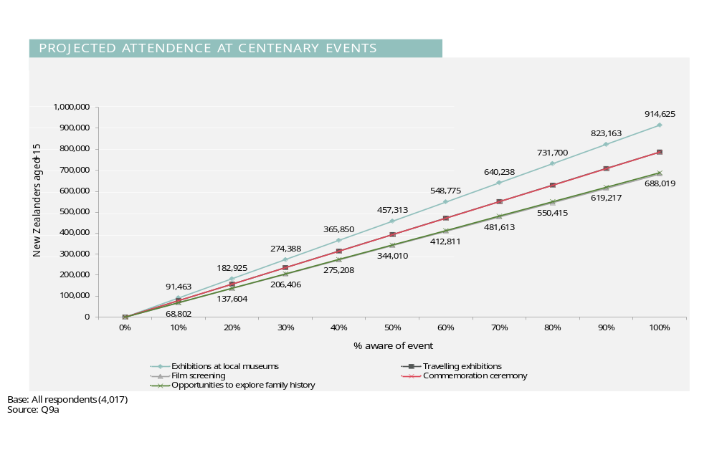
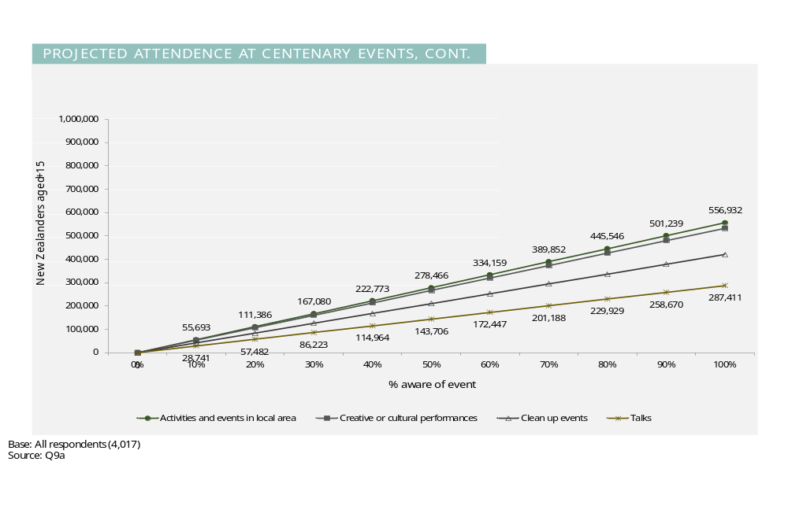

Interest in exhibit types
Respondents who indicated some likelihood of attending an exhibition at a local museum or a travelling exhibition were then asked what types of exhibits they would be interested in.
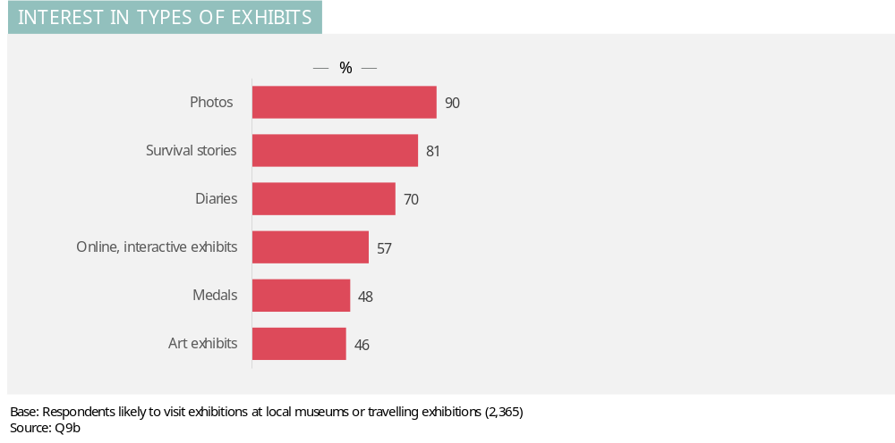
Among those interested in visiting exhibitions, photographic exhibitions hold the most appeal (90%) followed by survival stories (81%) and diaries (70%).
Demographic analysis shows a number of interesting variations by ethnicity and age:
- Females show stronger interest than males in survival stories (85% versus 76%), diaries (76% versus 62%), and art exhibits (51% versus 41%). Conversely, males show somewhat stronger interest than women in online interactive exhibits (59% versus 55%).
- Pacific people show especially strong interest in survival stories (91% compared to 81% on average) and art exhibits (58% compared to 46% on average).
- Maori show a higher than average level of interest in medals (55% versus 48%).
- Other Europeans are especially interested in diaries (77% compared to 70% on average).
- Northland residents show high interest in photos (97% versus 90% on average), Bay of Plenty residents show high interest in diaries (78% versus 70% on average) and Gisborne residents show high interest in online, interactive exhibits (79% versus 57% on average).

Likelihood of visiting a recreation of First World War trench
Respondents were asked how likely or unlikely they would be to go through a recreation of a First World War trench if it was at their local museum. A five point scale was used from 1 to 5 where 1 is ‘very unlikely’ and 5 is ‘very likely’. Those who indicated they were likely (a 4 or 5 out of 5) were then asked which trench they would be more interested in.
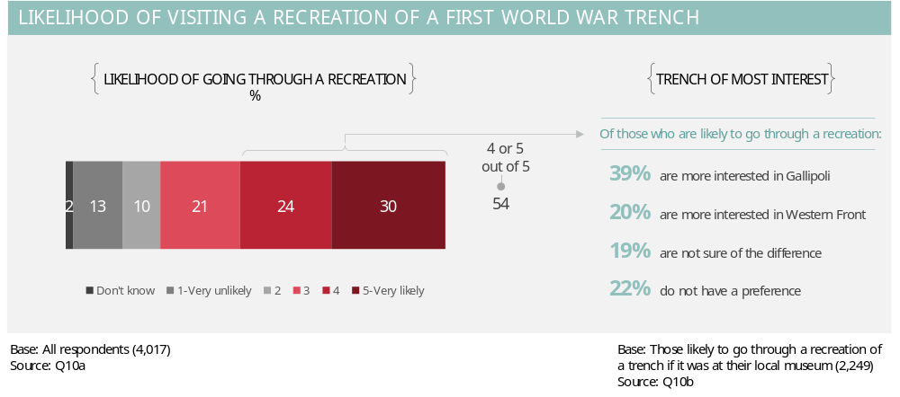

A recreation of a First World War trench holds notable appeal with three in ten New Zealanders saying they would be very likely to go through one at their local museum. Among those who indicated they would be likely to go through a recreation of a trench, Gallipoli holds the most appeal (39%).
Demographic analysis shows that 50-59 year olds are the age group exhibiting the most interest (35% say they are very likely). Interest is also higher in Southland and Canterbury (40% and 38% respectively say they are very likely).

If we use the same formula as earlier to convert stated likelihood to likely visitation, then for example around 200,000 New Zealanders will visit a WW1 trench assuming 20% awareness and accessibility.
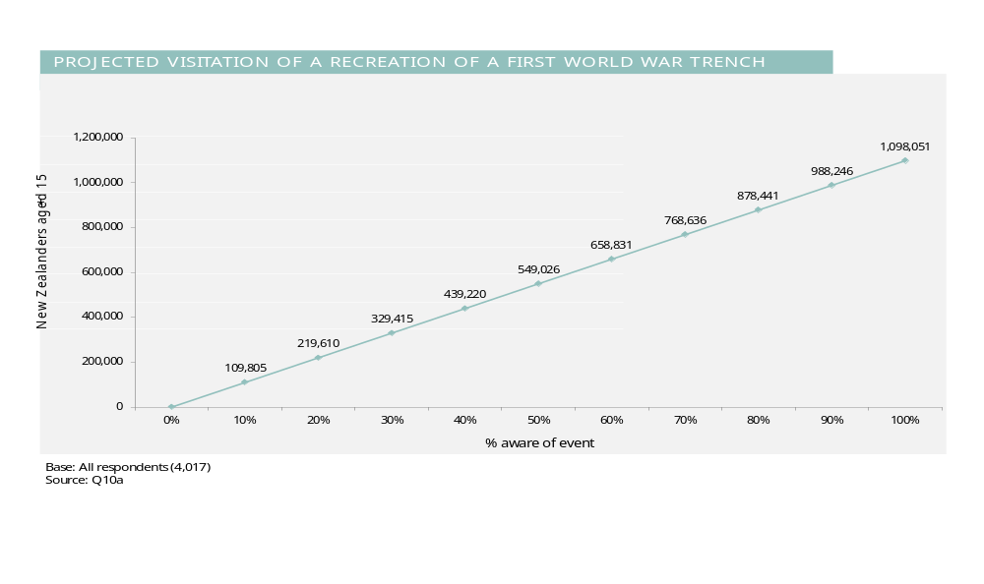

Interest in national online database of First World War NZ soldiers
Respondents were asked how interested they would be in using/and or contributing to a national online database that gathers the details of each New Zealand soldier who served in the First World War. A five point scale was used where 1 is ‘not at all interested’ and 5 is ‘very interested’.
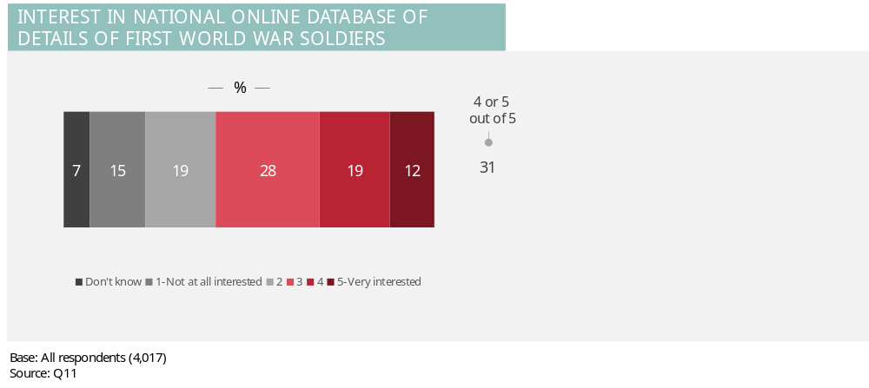
A small majority of people (60%) show some level of interest in this concept. Just over one in ten (12%) indicate they are very interested.

Demographic analysis
The chart below shows the proportion of respondents who are very interested (rating of 5 out of 5) in the concept on the national online database for each of the key demographic groups.
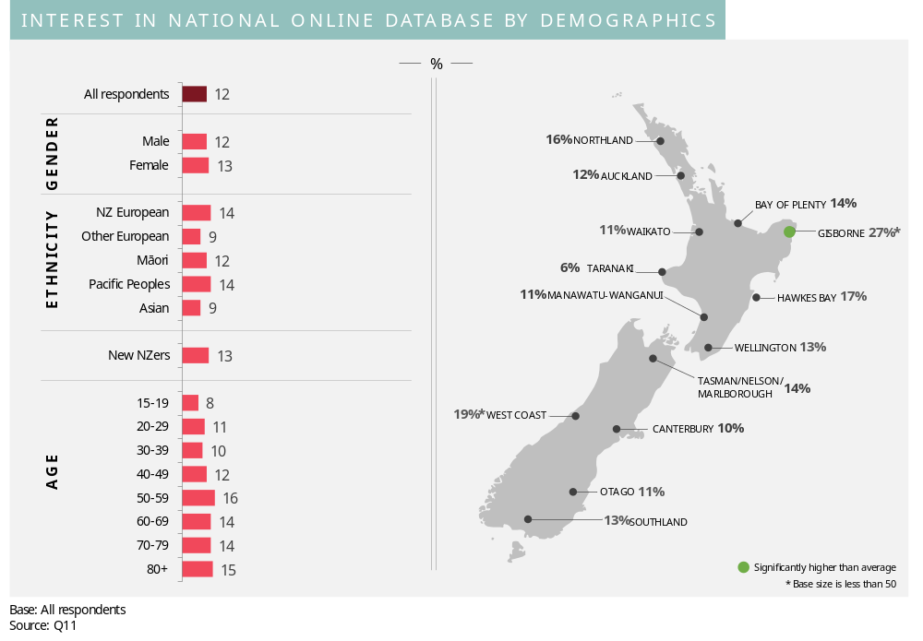
Interest is notably higher among 50-59 year olds and those living in Gisborne.

Interest in sharing memorabilia via national collection
Respondents were asked whether they have any memorabilia from the First World War. Those who do were then asked how interested they would be in having the memorabilia copied into digital (computerised) format for inclusion in a national collection that anyone could access online. A five point scale was used where 1 is ‘not at all interested’ and 5 is ‘very interested’.
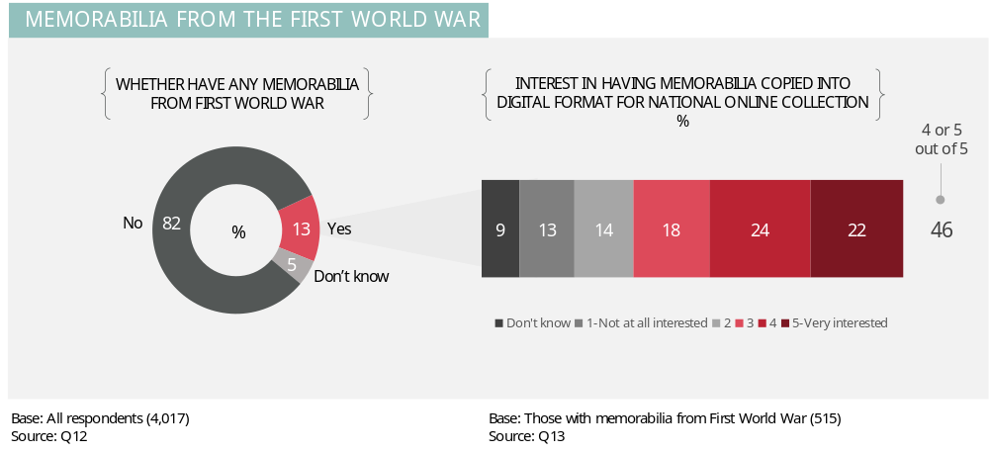
Around one in seven (13%) have memorabilia from the First World War. Of these, 64% show some level of interest in having their memorabilia included in the national collection. Around one in five (22%) of those with memorabilia say they are ‘very interested’.

Demographic analysis
The chart below shows the proportion of people with memorabilia from the First World War for each demographic group.
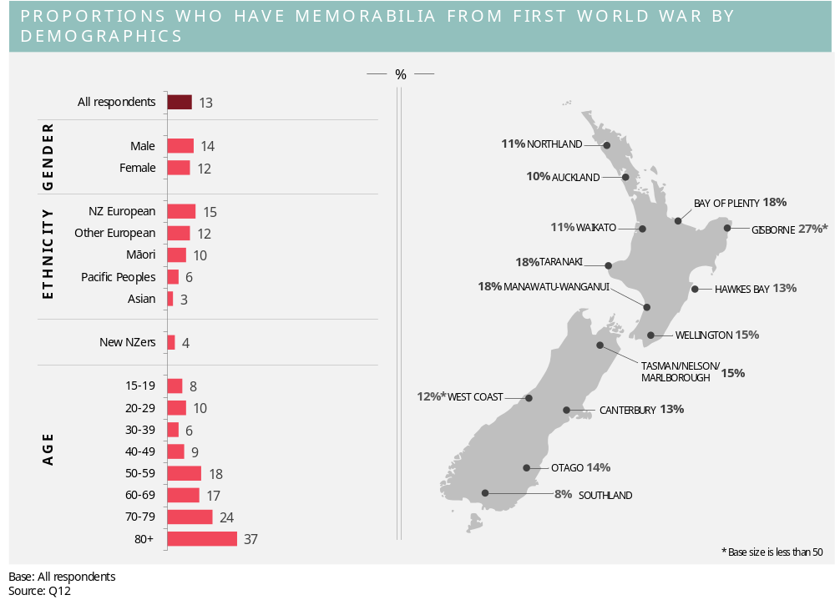There are especially strong patterns by age, with those aged 50 years plus more likely to have memorabilia than those aged under 50 years (20% versus 8%). Among those aged 50 years or more, the incidence of having memorabilia climbs steeply as age increases.
Among those who have memorabilia, there are no statistically significant variations across the demographic groups in the level of interest in including memorabilia in the national database.

Appendix A: Detailed sample profile
Age
 | Unweighted |  | Weighted
 | n=4,017 | % | n=4,019 | %
15 – 19 years | 407 | 10% | 401 | 10%
20 – 29 years | 595 | 15% | 557 | 14%
30 – 39 years | 790 | 20% | 818 | 20%
40 – 49 years | 736 | 18% | 726 | 18%
50 – 59 years | 609 | 15% | 631 | 16%
60 – 69 years | 460 | 11% | 446 | 11%
70 – 79 years | 332 | 8% | 346 | 9%
80+ years | 88 | 2% | 93 | 2%
Base: All respondents
Source: QS5
Gender
 | Unweighted |  | Weighted
 | n=4,017 | % | n=4,019 | %
Male | 1,929 | 48% | 1,934 | 48%
Female | 2,088 | 52% | 2,084 | 52%
Base: All respondents
Source: QS3
Country of birth
 | Unweighted |  | Weighted
 | n=4,017 | % | n=4,109 | %
New Zealand | 3,097 | 77% | 2,903 | 72%
United Kingdom | 302 | 8% | 268 | 7%
Other parts of Asia | 90 | 2% | 143 | 4%
India | 73 | 2% | 79 | 2%
Other part of Europe | 64 | 2% | 64 | 2%
Australia | 60 | 1% | 66 | 2%
China | 60 | 1% | 66 | 2%
South Africa | 57 | 1% | 80 | 2%
Pacific Islands | 53 | 1% | 112 | 3%
USA | 19 | 0% | 20 | 0%
Canada | 13 | 0% | 11 | 0%
South America | 5 | 0% | 8 | 0%
Somewhere else | 115 | 3% | 184 | 5%
Don't know | 9 | 0% | 15 | 0%
Base: All respondents
Source: Q33
Length of time in New Zealand
 | Unweighted |  | Weighted
 | n=920 | % | n=1116 | %
1 year or less | 2 | 0% | 1 | 0%
2-3 years | 19 | 2% | 26 | 2%
4-5 years | 45 | 5% | 48 | 4%
6-9 years | 151 | 16% | 222 | 20%
10-14 years | 207 | 22% | 268 | 24%
15-19 years | 116 | 13% | 134 | 12%
20 years or more | 371 | 40% | 402 | 36%
Don’t know | 9 | 1% | 15 | 1%
Base: All respondents who were born outside of New Zealand
Source: Q34

Region
 | Unweighted |  | Weighted
 | n=4017 | % | n=4019 | %
Northland Region | 139 | 3% | 145 | 4%
Auckland Region (includes the area from the Bombay Hills up to Wellsford) | 1,288 | 32% | 1,290 | 32%
Waikato Region | 377 | 9% | 375 | 9%
Bay of Plenty Region | 247 | 6% | 252 | 6%
Gisborne Region | 40 | 1% | 42 | 1%
Hawke's Bay Region | 144 | 4% | 145 | 4%
Taranaki Region | 103 | 3% | 104 | 3%
Manawatu-Wanganui Region | 223 | 6% | 221 | 5%
Wellington Region (includes Kapiti and the Wairarapa) | 456 | 11% | 453 | 11%
Tasman Region | 39 | 1% | 45 | 1%
Nelson Region | 44 | 1% | 45 | 1%
Marlborough Region | 45 | 1% | 44 | 1%
West Coast Region | 32 | 1% | 32 | 1%
Canterbury Region | 541 | 13% | 533 | 13%
Otago Region | 209 | 5% | 203 | 5%
Southland Region | 90 | 2% | 91 | 2%
Base: All respondents
Source: QS1
Waikato
 | Unweighted |  | Weighted
 | n=377 | % | n=375 | %
Hamilton | 150 | 40% | 142 | 38%
Outside of Hamilton | 227 | 60% | 233 | 62%
Base: All Waikato respondents
Source: Q35a
Wellington
 | Unweighted |  | Weighted
 | n=456 | % | n=453 | %
Wellington city | 306 | 67% | 304 | 67%
Outside of Wellington city | 150 | 33% | 149 | 33%
Base: All Wellington respondents
Source: Q35b
Canterbury
 | Unweighted |  | Weighted
 | n=541 | % | n=533 | %
Christchurch | 345 | 64% | 345 | 65%
Outside of Christchurch | 196 | 36% | 188 | 35%
Base: All Canterbury respondents
Source: Q35c
Dunedin
 | Unweighted |  | Weighted
 | n=209 | % | n=203 | %
Dunedin | 129 | 62% | 125 | 62%
Outside of Dunedin | 80 | 38% | 78 | 38%
Base: All Dunedin respondents
Source: Q35d

Auckland
 | Unweighted |  | Weighted
 | n=1288 | % | n=1290 | %
Albany (Albany, Browns Bay, Campbells Bay, Greenhithe, Hobsonville, Mairangi Bay, Matakana, Northcross, Orewa, Paremoremo, Pinehill, Silverdale, Wainoni, Waiwera, Whangaparoa, Whenuapai) | 151 | 12% | 138 | 11%
Rodney (Helensville, Huapai, Kawau Island, Kumeu, Warkworth, Wellsford)  North Shore (Beach Haven, Birkdale, Birkenhead, Castor Bay, Chatswood, Devonport, Glenfield, Hillcrest, Marlborough, Northcote, Stanley Bay, Sunnynook, Takapuna) | 53 | 4% | 42 | 3%
North Shore (Beach Haven, Birkdale, Birkenhead, Castor Bay, Chatswood, Devonport, Glenfield, Hillcrest, Marlborough, Northcote, Stanley Bay, Sunnynook, Takapuna) | 189 | 15% | 177 | 14%
Waitakere (French Bay, Glendene, Glen Eden, Henderson, Laingholm, Massey, O’Neill Bay, Oratia, Ranui, TeAtatu, Titirangi, Waiatarua, Waitakere, West Harbour, Westgate, Whatipu, Wood Bay, Woodlands Park) | 143 | 11% | 133 | 10%
Waitemata& Gulf (Auckland CBD, Great Barrier, Grey Lynn, Herne Bay, Newmarket, Parnell, Ponsonby, St Mary’s Bay, Waiheke, Westmere) | 56 | 4% | 67 | 5%
Albert-Eden-Roskill (Balmoral, Epsom, Greenlane, Hillsborough, Kingsland, Lynfield, Maungawhau, Morningside, Mt Albert, Mt Eden, Mt Roskill, Owairaka, Pt Chevalier, Sandringham, Three Kings, Waterview, Waikowhai, Wesley) | 141 | 11% | 154 | 12%
Whau (Avondale, Blockhouse Bay, Green Bay, Kelston, New Lynn, New Windsor, Rosebank) | 39 | 3% | 43 | 3%
Orakei (Ellerslie, Glendowie, Kohimarama, Meadowbank, Mission Bay, Orakei, Remuera, St Heliers, St Johns) | 93 | 7% | 86 | 7%
Maungakiekie-Tamaki (Glen Innes, Mt Wellington, Onehunga, One Tree Hill, Oranga, Panmure, Penrose, Pt England, Royal Oak, TePapapa) | 66 | 5% | 65 | 5%
Howick (Botany, Bucklands Beach, Cockle Bay, Dannemora, East Tamaki, Eastern Beach, Farm Cove, Flat Bush, Half Moon Bay, Highland Park, Howick, Mellons Bay, Northpark, Pakuranga, Shelly Park, Somerville, Sunnyhills) | 108 | 8% | 100 | 8%
Manukau (East Tamaki, Favona, Mangere, Manukau Central, Middlemore, Otahuhu, Otara, Papatoetoe, Puhunui) | 85 | 7% | 119 | 9%
Manurewa-Papakura (Alfriston, Homai, Manurewa, Pahurehure, Papakura, Red Hill, Takanini, Wattle Downs, Weymouth, Wiri) | 75 | 6% | 92 | 7%
Franklin (Ardmore, Awhitu, Beachlands, Clevedon, Drury, Franklin, Hingaia, Karaka, Kawakawa Bay, Maraetai, Orere Point, Pukekohe, Waiuku, Whitford) | 65 | 5% | 50 | 4%
Somewhere else | 24 | 2% | 25 | 2%
Base: All Auckland respondents
Source: Q35e
Household composition
 | Unweighted |  | Weighted
 | n=4,017 | % | n=4,019 | %
Dependent children under the age of 18 | 2,711 | 67% | 2,701 | 67%
At least one dependent child under the age of 5 | 542 | 13% | 535 | 13%
At least one dependent child between 5 and 12 years old | 661 | 16% | 661 | 16%
At least one dependent child between 13 and 17 years old | 442 | 11% | 444 | 11%
Live with a partner | 2,688 | 67% | 2,668 | 66%
Do not live with a partner | 1,329 | 33% | 1,350 | 34%
Base: All respondents
Source: Q36 and Q41

Highest education qualification
 | Unweighted |  | Weighted
 | n= | % | n= | %
No qualification | 300 | 7% | 305 | 8%
School Certificate or NCEA level 1 | 416 | 10% | 412 | 10%
Sixth Form Certificate, University Entrance or NCEA Level 2 | 492 | 12% | 500 | 12%
Bursary, Scholarship or NCEA level 3 or 4 | 246 | 6% | 239 | 6%
A Trade Qualification | 290 | 7% | 285 | 7%
A certificate or diploma that does not require a degree | 681 | 17% | 670 | 17%
A university degree | 773 | 19% | 770 | 19%
A polytech degree | 137 | 3% | 139 | 3%
Postgraduate qualification, eg Honours, Masters, Doctorate, Fellowship, Postgraduate Diploma | 506 | 13% | 504 | 13%
Other | 130 | 3% | 130 | 3%
Don't know | 46 | 1% | 65 | 2%
Base: All respondents
Source: Q38
Ethnicity (multicode)
 | Unweighted |  | Weighted
 | n=4,017 | % | n=4,019 | %
New Zealand European | 3,190 | 79% | 2,572 | 64%
Other European | 254 | 6% | 196 | 5%
Maori | 413 | 10% | 483 | 12%
Pacific | 140 | 3% | 242 | 6%
Asian | 340 | 8% | 363 | 9%
Other | 41 | 1% | 159 | 4%
Don’t know | 37 | 1% | 182 | 5%
Base: All respondents
Source: QS4
Electoral enrolment of Maori
 | Unweighted |  | Weighted
 | n=410 | % | n=482 | %
Maori Electoral Roll | 180 | 44% | 281 | 58%
General Electoral Roll | 188 | 46% | 163 | 34%
Not enrolled | 25 | 6% | 23 | 5%
Unsure | 17 | 4% | 14 | 3%
Base: All Maori respondents
Source: Q40
Income
 | Unweighted |  | Weighted
 | n=4,017 | % | n=4,109 | %
$20,000 or less | 392 | 10% | 383 | 10%
$20,001 to $30,000 | 283 | 7% | 287 | 7%
$30,001 to $50,000 | 535 | 13% | 536 | 13%
$50,001 to $70,000 | 555 | 14% | 577 | 14%
$70,001 to $100,000 | 645 | 16% | 642 | 16%
$100,001 to $120,000 | 384 | 10% | 371 | 9%
More than $120,000 | 493 | 12% | 452 | 11%
Don't know | 126 | 3% | 141 | 4%
Prefer not to say | 604 | 15% | 629 | 16%
Base: All respondents
Source: Q42and 42b

Appendix B: Final questionnaire

SURVEY ON THE FIRST WORLD WAR:
FINAL QUESTIONNAIRE

Introductory email invitation for Fly Buys panellists

SUBJECT: Survey for Ministry for Culture and Heritage

Hi [INSERT FIRST NAME]

We'd like to invite you to take part in today’s study for the Ministry for Culture and Heritage.

If you qualify and complete this survey you'll collect 20 Fly Buys Points! These points will show up on your Fly Buys account approximately 14 days after the survey close date.

It should take around 15 minutes to complete this survey, depending on your answers. We hope you find it interesting!

So that your views can be included we need you to finish the survey by Monday, 10 December 2012. This survey may close earlier if our target number has been reached.

Your answers are completely confidential. Your views will be grouped with those of others so that individual people and their answers cannot be identified.

To start, just click on the link below. If you need to, you can stop the survey at any time on the way through and return to the same point at a later date.

[INSERT UNIQUE LINK]

If your link wraps over two lines you may need to enter a code and password, these are:

Code: [INSERT CODE]
Password: [INSERT PASSWORD]

Thanks, in advance, for your time and your views!
Colmar Brunton

PS If there are other Fly Buys cardholders in your household that would like to register to collect Fly Buys Points with Colmar Brunton, just click here.

If you would like to contact us about this survey, simply reply to this email or alternatively email us at survey@colmarbrunton.co.nz

Please click here if you don't want to receive any more emails about this particular survey.
Please click here if you no longer wish to collect Fly Buys Points via Colmar Brunton online surveys.

Introductory text (first screen)
Thanks for agreeing to do today’s survey for the Ministry for Culture and Heritage.

The survey should take 10 to 15 minutes to complete, depending on your answers.

Please click the arrow below to continue.

Screening questions
Thanks for agreeing to do today’s survey. Firstly we have a few questions to ensure we’re surveying a wide range of people.

S1 In which of the following regions do you live?
Please select one only.

Northland Region | 1
Auckland Region (includes the area from the Bombay Hills up to Wellsford) | 2
Waikato Region | 3
Bay of Plenty Region | 4
Gisborne Region | 5
Hawke's Bay Region | 6
Taranaki Region | 7
Manawatu-Wanganui Region | 8
Wellington Region (includes Kapiti and the Wairarapa) | 9
Tasman Region | 10
Nelson Region | 11
Marlborough Region | 12
West Coast Region | 13
Canterbury Region | 14
Otago Region | 15
Southland Region | 16

S2 What is your current status in New Zealand?
Please select one only.

New Zealand citizen | 1
Permanent resident | 2
Temporary resident | CLOSE
Other | CLOSE

S3 Are you…?
Please select one only.

Male | 1
Female | 2

S4 Which of these groups do you fit into? You can be in more than one.
Please select all that apply.

New Zealand European | 1
New Zealand Māori | 2
Samoan | 3
Cook Island Māori | 4
Tongan | 5
Niuean | 6
Another Pacific Island group (please type in) | 7
Chinese | 8
Indian | 9
Another Asian group (please type in) | 10
Another European group (please type in) | 11
Another ethnic group (please type in) | 12
SINGLE CODE ONLY: Don’t know | 13
SINGLE CODE ONLY: Prefer not to say | 14

S5 Which of the following age groups are you in?
Please select one only.

15 - 19 | 1
20 - 24 | 2
25 - 29 | 3
30 - 34 | 4
35 - 39 | 5
40 - 44 | 6
45 - 49 | 7
50 - 54 | 8
55 - 59 | 9
60 - 64 | 10
65 - 69 | 11
70 - 74 | 12
75 – 79 | 13
80 – 84 | 14
85 years plus | 15
Prefer not to say | 16

IF QUOTA FULL CLOSE WITH: I’m sorry. We have already surveyed a lot of people in a similar demographic group to you. Thank you very much for your interest.

History
First, we have several questions about your interest in history.

1a How interested are you in history?
Please select one answer only.

1 = Not at all interested | 1
2 | 2
3 | 3
4 | 4
5 = Very interested | 5
Don’t know | 6

1b In your opinion, what is the most important and significant event since 1900 until today?
Please type your answer in below.
DP INSTRUCTION: INCLUDE TICK BOX FOR ‘Don’t know’

ASK IF CODES 3-5 AT 1a. OTHERWISE GO TO 2a.
1c Where do you like learning or finding out about history?
Please select all that apply.

TV | 1
Books | 2
Internet | 3
Museum | 4
School | 5
Other (please type in answer) | 6
Don’t know | 7

2a How interested are you in family history/genealogy?
Please select one answer only.

1 = Not at all interested | 1
2 | 2
3 | 3
4 | 4
5 = Very interested | 5
Don’t know | 6

2b Have you, or someone else in your family, undertaken any research into your own family history/genealogy?
Please select one answer only.

Yes – I have personally | 1 | ASK 2c
Yes – someone else in my family has | 2 | GO TO 3a
No – I/our family has not | 3 | GO TO 3a
Don’t know | 4 | GO TO 3a

2c What resources did you use?
Please select all that apply.

Internet/online resources | 1
Spoke with/wrote to/emailed family members | 2
Family papers/documents | 3
Newspapers/Births, Deaths and Marriages | 4
Library | 5
Local community organisation | 6
Cemeteries | 7
Other (please type in answer) | 8
SINGLE CODE ONLY: Don’t know | 9

3a How interested are you in the history of your local community?
Please select one answer only.

1 = Not at all interested | 1
2 | 2
3 | 3
4 | 4
5 = Very interested | 5
Don’t know | 6

ASK IF CODES 3-5 AT 3a. OTHERWISE GO TO INTRO BEFORE Q4.
3b Have you undertaken any research, or looked into, into the history of your local community?
Please select one answer only.

Yes | 1 | ASK 3c
No | 2 | GO TO INTRO B4 Q4

3c What resources did you use?
Please select all that apply.

Internet/online resources | 1
Newspapers | 2
Library | 3
Museum | 4
Local community organisation | 5
Spoke with local residents/knowledgeable people | 6
Cemeteries | 7
Other (please type in answer) | 8

Introducing the topic of the First World War and the Commemorations

The rest of this survey is about the First World War,

4 What words come to mind when you hear the words, the First World War?
Please type your answer in below.
DP INSTRUCTION: INCLUDE TICK BOXES FOR ‘Nothing’ and ‘Never heard of the First World War’.

IF RESPONDENT TICKS ‘NEVER HEARD OF THE FIRST WORLD WAR BOX’ SKIP TO Q32.

5a How important do you think it is for New Zealand to commemorate the Centenary of the First World War?
Please select one answer only.

1 = Not at all important | 1
2 | 2
3 | 3
4 | 4
5 = Very important | 5
Don’t know | 6 | GO TO 6a

5b IF CODE 1 AT 5a: For what reasons do you think it’s not important to commemorate the Centenary of the First World War?

IF CODE 2 OR 3 AT 5a: For what reasons do you think it’s not that important to commemorate the Centenary of the First World War?

IF CODES 4 OR 5 AT 5a: For what reasons do you think it’s important to commemorate the Centenary of the First World War?

Please type your answer in below.
DP INSTRUCTION: INCLUDE TICK BOX FOR ‘Don’t know’

6a Before today, were you aware that the Government will be funding some projects to commemorate the First World War?
Please select one answer only.

Yes | 1 | ASK 6b
No | 2 | GO TO 7
Don’t know | 3 | GO TO 7

6b Which of these projects are you aware of?
Please select all that apply.

Development of the National War Memorial Park | 1
Education and Interpretative Centre | 2
Contribution to Cenotaph database | 3
Heritage ‘trail’ across battlefield of significant sites in Europe | 4
Another project (please type in answer) | 5
Not aware of any of these | 6

7 Are you aware that the Lottery Grants Board has funding available for community projects to commemorate the First World War?
Please select one answer only.

Yes | 1
No | 2
Don’t know | 3

8 Would you, or a group you belong to, consider organising something to commemorate the First World War?
Please select one answer only.

Yes | 1
No | 2
Don’t know | 3

9a How likely or unlikely would you be to attend the following kinds of centenary events related to the First World War if they were made available? These would be held over the next four years.
Please select one answer only for each event.
DP INSTRUCTION: ROTATE STATEMENTS

 | 1=very unlikely | 2 | 3 | 4 | 5= very likely | Don’t know
Commemoration ceremony (e.g. dawn service or other type of ceremony) | 1 | 2 | 3 | 4 | 5 | 6
Film screenings | 1 | 2 | 3 | 4 | 5 | 6
Talks | 1 | 2 | 3 | 4 | 5 | 6
Opportunities to explore your family history related to the First World War (e.g. genealogy workshops) | 1 | 2 | 3 | 4 | 5 | 6
Exhibitions at local museums | 1 | 2 | 3 | 4 | 5 | 6
Travelling exhibitions that move around the country visiting major towns and smaller communities | 1 | 2 | 3 | 4 | 5 | 6
Activities and events in your local area that explore the involvement of the community in the First World War | 1 | 2 | 3 | 4 | 5 | 6
‘Clean up’ events at local memorials | 1 | 2 | 3 | 4 | 5 | 6
Creative or cultural performances related to the First World War (e.g. play, movie, song, dance, photography) | 1 | 2 | 3 | 4 | 5 | 6

ASK IF CODES 4 OR 5 FOR ‘EXHIBITIONS AT LOCAL MUSEUMS’ OR ‘TRAVELLING EXHIBITIONS’ AT 9a:
9b What type of exhibits would you be interested in?
Please select all that apply.

Photos | 1
Medals | 2
Diaries | 3
Survival stories | 4
Online, interactive exhibits | 5
Art exhibits | 6
Another type of exhibit (please type in answer) | 7
SINGLE CODE ONLY: Don’t know | 8

10a How likely or unlikely would you be to go through a recreation of a First World War trench if it was at your local museum?
Please select one answer only.

1 = Very unlikely | 1
2 | 2
3 | 3
4 | 4
5 = Very likely | 5
Don’t know | 6

ASK IF CODES 4 OR 5 AT 10a:
10b Which trench would you be more interested in?
Please select one answer only.

Gallipoli | 1
Western Front | 2
I’m not sure of the difference | 3
No preference | 4

11 How interested would you be in using and/or contributing to a national online database that gathers the details of each New Zealand soldier who served in the First World War?
Please select one answer only.

1 = Not at all interested | 1
2 | 2
3 | 3
4 | 4
5 = Very interested | 5
Don’t know | 6

12 Do you have any memorabilia from the First World War?
Please select one answer only.

Yes | 1 | ASK 13
No | 2 | GO TO 14
Don’t know | 3 | GO TO 14

13 How interested would you be in having the memorabilia copied into digital (computerised) format for inclusion in a national collection that anyone could access online?
Please select one answer only.

1 = Not at all interested | 1
2 | 2
3 | 3
4 | 4
5 = Very interested | 5
Don’t know | 6

Sources of awareness and knowledge of the First World War

14 In the last three months, where have you seen or heard the First World War mentioned?
Please select all that apply.

TV | 1
Radio | 2
Newspaper/magazines | 3
Internet | 4
Somewhere else (please type in answer) | 5
Nowhere | 6
SINGLE CODE ONLY: Don’t know | 7

15a Which of these have you done?
Please answer yes or no for each item.
DP INSTRUCTION: ROTATE STATEMENTS

 | Yes | No | Don’t know
Studied the First World War at school | 1 | 2 | 3
Watched a TV documentary about the First World War | 1 | 2 | 3
Watched a fictional TV programme about the First World War | 1 | 2 | 3
Looked up the First World War online | 1 | 2 | 3
Read a non-fiction book about the First World War | 1 | 2 | 3
Read a fictional book about the First World War | 1 | 2 | 3
Read a poem about the First World War | 1 | 2 | 3
Seen a movie about the First World War | 1 | 2 | 3
Been to a First World War battle site | 1 | 2 | 3
Visited a museum or exhibit relevant to the First World War | 1 | 2 | 3
Met a First World War veteran | 1 | 2 | 3
Been to an Anzac ceremony or other commemorative service | 1 | 2 | 3
Bought a poppy | 1 | 2 | 3
Followed an Anzac ceremony or other commemorative service on TV/Radio | 1 | 2 | 3
Read about the First World War in the newspaper | 1 | 2 | 3
Something else (please type in) | 1 | 2 | 3

16a If you were given the opportunity to meet an expert about the First World War, what would you ask them about?
Please type your answer in below.
DP INSTRUCTION: INCLUDE TICK BOXES FOR ‘Not interested in asking them anything’ and ‘Don’t know’.

Knowledge of the First World War

17 Which of the statements below best describes how much you know about New Zealand’s involvement in the First World War?
Please select one answer only.

I had never heard of the First World War before this survey | 1 | GO TO Q32
I have heard of the First World War but have no real knowledge of it | 2
I have a basic understanding of the First World War | 3
I know a reasonable amount about the First World War | 4
I have a reasonably advanced level of understanding about the First World War | 5
I have expert knowledge about the First World War, its causes, the reason for this country’s involvement and the campaigns and major battles fought by New Zealanders. | 6
Don’t know | 7

18 What thoughts come to mind when you think about New Zealand’s involvement during the First World War?
Please type your answer in below.
DP INSTRUCTION: INCLUDE TICK BOX FOR ‘Nothing.’

We’re interested in finding out what New Zealanders know about different aspects of the First World War. It’s important that you answer these next questions only based on what you currently know and don’t refer to anyone or anything else. If you don’t know the answer, that’s fine, simply click the box to indicate you don’t know.

19 What does the term Anzac stand for?
Please select one answer only.

Australian and New Zealand Artillery Company | 1
Australian and New Zealand Army Club | 2
American and New Zealand Army Club | 3
Australian and New Zealand Army Corps | 4
Don’t know | 5

20 What do you know about the origins of Anzac Day?
Please type your answer in below.
DP INSTRUCTION: INCLUDE TICK BOX FOR ‘Don’t know anything about this’.

21 Why did New Zealand troops fight in the First World War?
Please type your answer in below.
DP INSTRUCTION: INCLUDE TICK BOX FOR ‘I don’t know’.

22 Did you know that New Zealand occupied Samoa in the First World War?
Please select one answer only.

Yes | 1
No | 2
Don’t know | 3

23 What do you know about Māori involvement in the First World War?
Please type your answer in below.
DP INSTRUCTION: INCLUDE TICK BOX FOR ‘Don’t know anything about this’.

24a In what year, did the First World War begin?

SLIDING SCALE TO BE CREATED FROM 1910 TO 1920. PLUS DON’T KNOW OPTION.

24b In what year, did the First World War end?

SLIDING SCALE TO BE CREATED FROM 1910 TO 1920. PLUS DON’T KNOW OPTION.

25a Which First World War fronts and battles are you aware of?
ROTATE STARTING POINT.
Please select all that apply
The Western Front
The Eastern Front
The Gallipoli Front
The Italian Front
The Palestine Front
Mesopotamian Front
The African Wars
The War at Sea
The Far East
Battle of Tannenberg
Battle of Arras
Battle of Gallipoli
Battle of Marnes
Serbian campaign
Battle of Passchendale
Battle of Verdun
Battle of the Somme
Battle of Le Quesnoy
Spring offensive
Hundred days offensive
Another battle (please type in answer)
SINGLE CODE ONLY: None/don’t know |  | GO TO 27

25b Which battle was the most important battle of the First World War for New Zealanders?
Please select one answer only.
DP INSTRUCTION: LIST BATTLES THAT RESPONDENT WAS AWARE OF AT Q25a.

26 As far as you know, where were more New Zealanders killed, Gallipoli or Western Front?
Please select one answer only.

Gallipoli | 1
Western Front | 2
Don’t know | 3

27 Overall, how relevant do you think the First World War has been in developing New Zealand’s national identity?
Please select one answer only.

1 = Not at all relevant | 1
2 | 2
3 | 3
4 | 4
5 = Very relevant | 5
Don’t know | 6

Family participation in First World War

Now a few questions about your family’s involvement in the First World War.

28a Did anyone in your family serve or fight in the First World War?
Please select one answer only.

Yes | 1 | ASK 28b
No | 2 | GO TO 31a
Don’t know | 3 | GO TO 31a

28b What relationship were they to you?
Please select all that apply

Father | 1
Grandfather | 2
Great grandfather | 3
Uncle | 4
Great Uncle | 5
Mother | 6
Grandmother | 7
Great grandmother | 8
Aunty | 9
Great Aunty | 10
Some other relationship (please type in answer) | 11
SINGLE CODE ONLY: Don’t know | 12

29 Have you talked to your family or friends about your family’s participation or experience during the First World War?
Please select one answer only.

Yes | 1
No | 2
Don’t know | 3

30 If you had the opportunity, would you like to find out more about your family’s involvement in the First World War?
Please select one answer only.

Yes | 1
No | 2
Don’t know | 3

31a How relevant is what happened in the First World War, and the outcome of the War, to your life today?
Please select one answer only.

1 = Not at all relevant | 1
2 | 2
3 | 3
4 | 4
5 = Very relevant | 5
Don’t know | 6

31b In your opinion, how important is the Australian relationship to New Zealand’s history?
Please select one answer only.

1 = Not at all important | 1
2 | 2
3 | 3
4 | 4
5 = Very important | 5
Don’t know | 6

31c Now that you have answered all of the questions about the First World War, how important do you think it is for New Zealand to commemorate the Centenary of the First World War? If your answer is the same as the one you gave earlier that’s fine.
Please select one answer only.

1 = Not at all important | 1
2 | 2
3 | 3
4 | 4
5 = Very important | 5
Don’t know | 6

Background and demographic questions
Finally, we have some background questions to make sure we get the views of a good cross section of New Zealanders.

32 We are all members of different social groups or categories. One of the social groups you belong to is New Zealand. How much do you agree or disagree with these statements?
Please select one answer only per statement
DP INSTRUCTION: ROTATE STATEMENTS

 | 1=Strongly agree | 2 | 3 | 4 | 5 | 6 | 7 | 8 = Strongly disagree | Don’t know
I often regret that I belong to New Zealand | 1 | 2 | 3 | 4 | 5 | 6 | 7 | 8 | 9
In general, I’m glad to be a member of New Zealand | 1 | 2 | 3 | 4 | 5 | 6 | 7 | 8 | 9
Overall I feel that being a member of New Zealand is worthwhile | 1 | 2 | 3 | 4 | 5 | 6 | 7 | 8 | 9
I feel good about belonging to New Zealand | 1 | 2 | 3 | 4 | 5 | 6 | 7 | 8 | 9
Overall, New Zealand has very little to do with how I feel about myself | 1 | 2 | 3 | 4 | 5 | 6 | 7 | 8 | 9
New Zealand is an important reflection of who I am | 1 | 2 | 3 | 4 | 5 | 6 | 7 | 8 | 9
New Zealand is unimportant to my sense of what kind of person I am | 1 | 2 | 3 | 4 | 5 | 6 | 7 | 8 | 9
In general, belonging to New Zealand is an important part of my self image | 1 | 2 | 3 | 4 | 5 | 6 | 7 | 8 | 9
I think of myself as a New Zealander | 1 | 2 | 3 | 4 | 5 | 6 | 7 | 8 | 9
It is important to me that I am a New Zealander | 1 | 2 | 3 | 4 | 5 | 6 | 7 | 8 | 9

33 Where were you born?
Please select one answer only.

New Zealand | 1 | GO TO 35
Australia | 2
Canada | 3
China | 4
India | 5
Pacific Islands | 6
South Africa | 7
South America | 8
USA | 9
United Kingdom | 10
Other part of Europe | 11
Other parts of Asia | 12
Somewhere else (please type in answer) | 13
Don’t know | 14

34 How long have you lived in New Zealand?
Please select one answer only.

1 year or less | 1
2-3 years | 2
4-5 years | 3
6-9 years | 4
10-14 years | 5
15-19 years | 6
20 years or more | 7
Don’t know | 8

ASK IF CODE 3 (WAIKATO) AT S1:
35a You indicated at the beginning of the survey that you live in the Waikato region. Do you live in Hamilton or outside of Hamilton?
Please select one answer only.

Hamilton | 1
Outside of Hamilton | 2

ASK IF CODE 9 (WELLINGTON REGION) AT S1:
35b You indicated at the beginning of the survey that you live in the Wellington region. Do you live in Wellington city (including Porirua and the Hutt) or outside of Wellington city?
Please select one answer only.

Wellington city | 1
Outside of Wellington city | 2

ASK IF CODE 14 (CANTERBURY) AT S1:
35c You indicated at the beginning of the survey that you live in the Canterbury region. Do you live in Christchurch or outside of Christchurch?
Please select one answer only.

Christchurch | 1
Outside of Christchurch | 2

ASK IF CODE 15 (OTAGO) AT S1:
35d You indicated at the beginning of the survey that you live in the Otago region. Do you live in Dunedin or outside of Dunedin?
Please select one answer only.

Dunedin | 1
Outside of Dunedin | 2

ASK IF CODE 2 (AUCKLAND) AT S1:
35e You indicated at the beginning of the survey that you live in the Auckland region. Which of the following best describes which area of Auckland you live in?
Please select one answer only.
DP INSTRUCTION: ROTATE STARTING POINT BETWEEN 1 AND 12. OTHER SHOULD ALWAYS BE LAST.
Albany (Albany, Browns Bay, Campbells Bay, Greenhithe, Hobsonville, Mairangi Bay, Matakana, Northcross, Orewa, Paremoremo, Pinehill, Silverdale, Wainoni, Waiwera, Whangaparoa, Whenuapai) | 1
Rodney (Helensville, Huapai, Kawau Island, Kumeu, Warkworth, Wellsford)  North Shore (Beach Haven, Birkdale, Birkenhead, Castor Bay, Chatswood, Devonport, Glenfield, Hillcrest, Marlborough, Northcote, Stanley Bay, Sunnynook, Takapuna) | 2
Waitakere (French Bay, Glendene, Glen Eden, Henderson, Laingholm, Massey, O’Neill Bay, Oratia, Ranui, TeAtatu, Titirangi, Waiatarua, Waitakere, West Harbour, Westgate, Whatipu, Wood Bay, Woodlands Park) | 3
Waitemata& Gulf (Auckland CBD, Great Barrier, Grey Lynn, Herne Bay, Newmarket, Parnell, Ponsonby, St Mary’s Bay, Waiheke, Westmere) | 4
Albert-Eden-Roskill (Balmoral, Epsom, Greenlane, Hillsborough, Kingsland, Lynfield, Maungawhau, Morningside, Mt Albert, Mt Eden, Mt Roskill, Owairaka, Pt Chevalier, Sandringham, Three Kings, Waterview, Waikowhai, Wesley) | 5
Whau (Avondale, Blockhouse Bay, Green Bay, Kelston, New Lynn, New Windsor, Rosebank) | 6
Orakei (Ellerslie, Glendowie, Kohimarama, Meadowbank, Mission Bay, Orakei, Remuera, St Heliers, St Johns) | 7
Maungakiekie-Tamaki (Glen Innes, Mt Wellington, Onehunga, One Tree Hill, Oranga, Panmure, Penrose, Pt England, Royal Oak, TePapapa) | 8
Howick (Botany, Bucklands Beach, Cockle Bay, Dannemora, East Tamaki, Eastern Beach, Farm Cove, Flat Bush, Half Moon Bay, Highland Park, Howick, Mellons Bay, Northpark, Pakuranga, Shelly Park, Somerville, Sunnyhills) | 9
Manukau (East Tamaki, Favona, Mangere, Manukau Central, Middlemore, Otahuhu, Otara, Papatoetoe, Puhunui) | 10
Manurewa-Papakura (Alfriston, Homai, Manurewa, Pahurehure, Papakura, Red Hill, Takanini, Wattle Downs, Weymouth, Wiri) | 11
Franklin (Ardmore, Awhitu, Beachlands, Clevedon, Drury, Franklin, Hingaia, Karaka, Kawakawa Bay, Maraetai, Orere Point, Pukekohe, Waiuku, Whitford) | 12
Somewhere else (please type in answer) | 13

36 Which of the following applies to you?
Please select all that apply.

SINGLE CODE ONLY: I have no dependent children under the age of 18 | 1
I have at least one dependent child under the age of 5 | 2
I have at least one dependent child between 5 and 12 years old | 3
I have at least one dependent child between 13 and 17 years old | 4

37 What is your occupation?
Please type your answer in below.
DP INSTRUCTION: INCLUDE TICK BOX FOR ‘Prefer not to say’.

38 What is the highest educational qualification you have?
Please select one answer only.

No qualification | 1
School Certificate or NCEA level 1 | 2
Sixth Form Certificate, University Entrance or NCEA Level 2 | 3
Bursary, Scholarship or NCEA level 3 or 4 | 4
A Trade Qualification | 5
A certificate or diploma that does not require a degree | 6
A university degree | 7
A polytech degree | 8
Postgraduate qualification, eg Honours, Masters, Doctorate, Fellowship, Postgraduate Diploma | 9
Other (please type in answer) | 10
Don’t know | 11

ASK IF MORE THAN ONE ETHNIC GROUP CODED AT S4:
39 You indicated at the beginning of the survey that you belong to more than one ethnic group. Which ethnic group do you most closely identify with?
Please select one answer only.
DP INSTRUCTION: LIST TO CONSIST OF CATEGORIES GIVEN IN PREVIOUS QUESTION.

ASK IF MAORI (CODE 2 AT S4):
40 Are you enrolled on the Māori Electoral Roll or the General Electoral Roll?
Please select one answer only.

Māori Electoral Roll | 1
General Electoral Roll | 2
Not enrolled | 3
Unsure | 4

41 Do you live with a partner or spouse?
Please select one only.

Yes | 1 | ASK 42a
No | 2 | GO TO 42b

42a What is the approximate combined annual income of you and your partner from all sources, before tax?
Please select one only.

$20,000 or less | 1 | SKIP TO CLOSE
$20,001 to $30,000 | 2 | SKIP TO CLOSE
$30,001 to $50,000 | 3 | SKIP TO CLOSE
$50,001 to $70,000 | 4 | SKIP TO CLOSE
$70,001 to $100,000 | 5 | SKIP TO CLOSE
$100,001 to $120,000 | 6 | SKIP TO CLOSE
More than $120,000 | 7 | SKIP TO CLOSE
Don’t know | 8 | SKIP TO CLOSE
Prefer not to say | 9 | SKIP TO CLOSE

42b What is your personal annual income from all sources, before tax?
Please select one only.

$5,000 or less | 1
$5,001 to $10,000 | 2
$10,001 to $20,000 | 3
$20,001 to $30,000 | 4
$30,001 to $50,000 | 5
$50,001 to $70,000 | 6
$70,001 to $100,000 | 7
$100,001 to $120,000 | 8
More than $120,000 | 9
Don’t know | 10
Prefer not to say | 11

Close

That’s the end of the survey. Thank you for your time today.

If you would like to know more about the First World War Centenary commemorations check out http://www100.govt.nz/INCLUDE POPPY LOGO

You have collected 20 Fly Buys Points for completing this survey. Please remember these points may take up to 14 days

The IWM and the Australian survey had a different sampling method thus only limited comparisons can be made.
This question was asked directly after the question asking respondents how relevant what happened in the First World War, and the outcome of the War, is to their life today. Respondents are therefore likely to have answered the subsequent question about the Australian relationship in the context of the First World War.

